Test 5 II variant (Options-5)
Ex.1 Write the jobs.
2  1  4  3  5  5 points | 1 4  2 5  3

Ex.2 Fill in with the appropriate verb from the list in Present Simple. One word is extra.

• go • get • have • watch • do • play •  1 Jessica ................ to the gym three times a week.  2. Bethany ............................. dinner at 7:00. | 3. My parents don’t ................................ TV.  4. What time do you ...................... up in the morning?  5. My brother and I …… our homework in the afternoon.  10 points

Ex.3
Complete the dialogue. One sentence doesn’t match.
A What time does the film start?
B Let’s meet outside the cinema.
C And what time does it finish?
D When is it open?
Tony: Hello, Bill.
Bill: Hi, Tony. Are you free tonight?
Tony: Yes, I am.
Bill: Do you want to go the cinema?
Tony: 1) .............................................................
Bill: At 6:00.
Tony: 2) .............................................................
Bill: At 8:30.
Tony: That’s OK with me.
Bill: Can we meet at 5:30?
Tony: Yes, that’s fine.
Bill: 3) .............................................................
Tony: OK! See you there. 6 points

Ex.4 Read Derek’s letter. Use the words below to complete the sentences. One word is extra.
• husband • mum • granddad • dad • uncle • grandma • family • sister • son • cousin
Dear Harry,
I am Ted White and I am 10 years old. This is a picture of my 1)................................. My 2)................... is Ben. He is 42 years old and very clever and strong. He can play football well. Patrisia is my 3).................... . She is 39 and a lovely person. My 4).................... is Ann. She is 70 and very kind. She is my father’s mother. Kavin is her 5)…… and my 6)....................... . He’s 72 and he is very funny. Mary is my little 7)….............. . She is 4 years old and very noisy. My 8).........................., Jhon Brown, is my father’s brother. His 9)........................... John is a popular singer. He is my favourite 10)................................ .
Have you got a big family?
Please, send a picture!
Take care,
Ted
10 points
Ex.5 Write questions and short answers as in the example.  0. you / study / English? (X) Do you study English? No, I don’t.  1. you / like /pop music? (V)  2. your grandmother / wear / glasses? (X) | 3. you / walk /to school? (V)  4. your teacher /have / lunch at school? (X)  5. we / go / to the cinema today? (V)  5 points

Total: 30 points

Ex.6 Look at the clock faces and write the time, as in the example. (You may Use: o’clock; half; quarter; past; to)
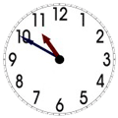  - It’s ten to eleven. | 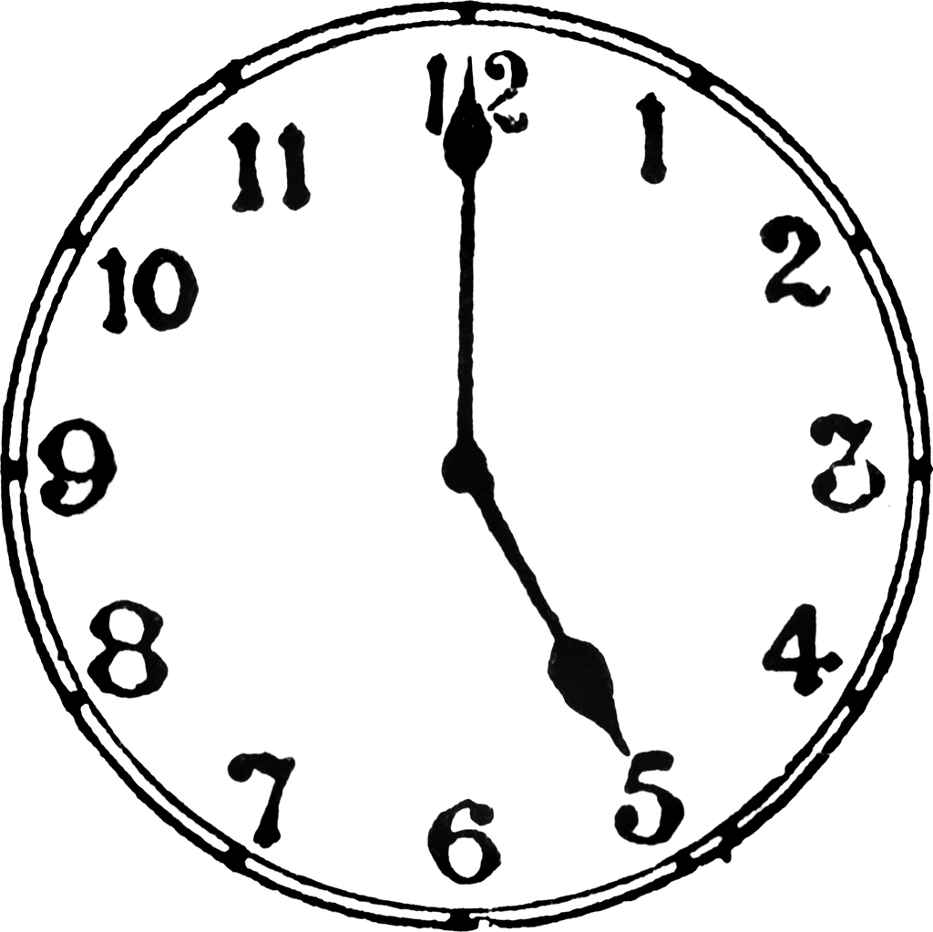 | 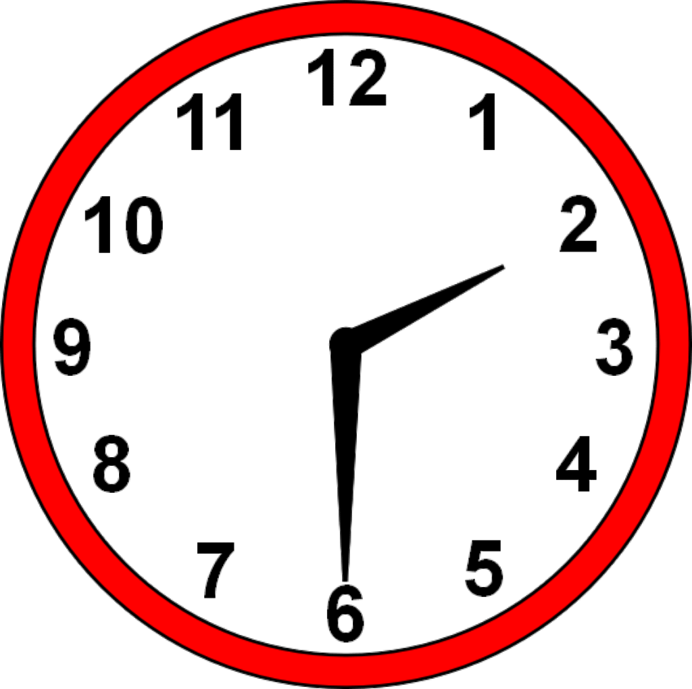  2.
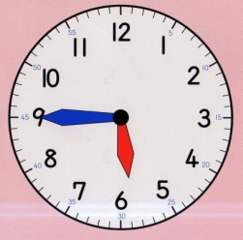  3. | 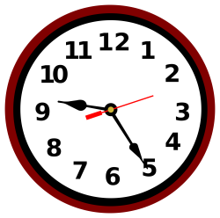  4. | 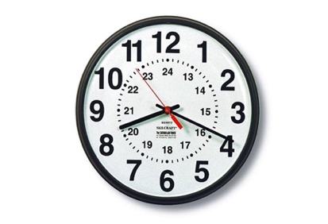  5.

