Test 4 Options-5
II variant
Ex.1 Vocabulary. Write the words to the pictures. (9*1=9 points)
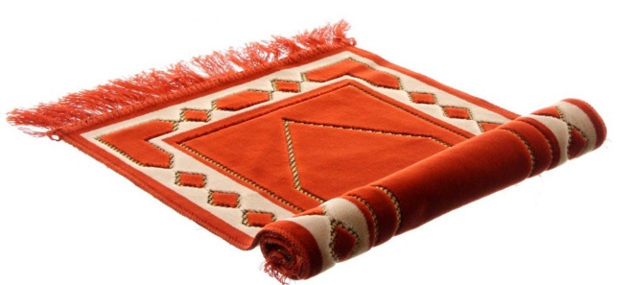  1 | 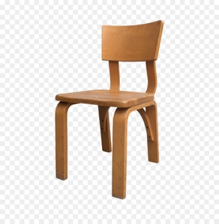  2 | 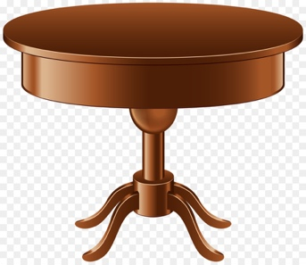  3
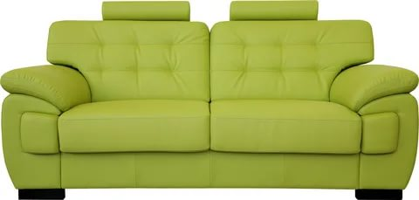  4 | 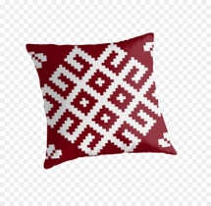  5 | 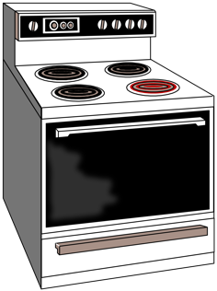  6
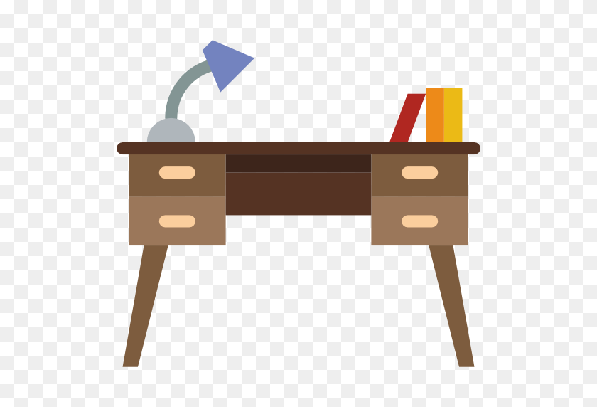  7 | 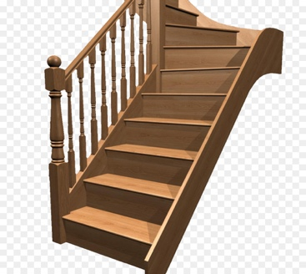  8 | 9

Ex.2 Grammar. Look at the picture. Complete the gaps with there is/there are. (6*2=12 points)
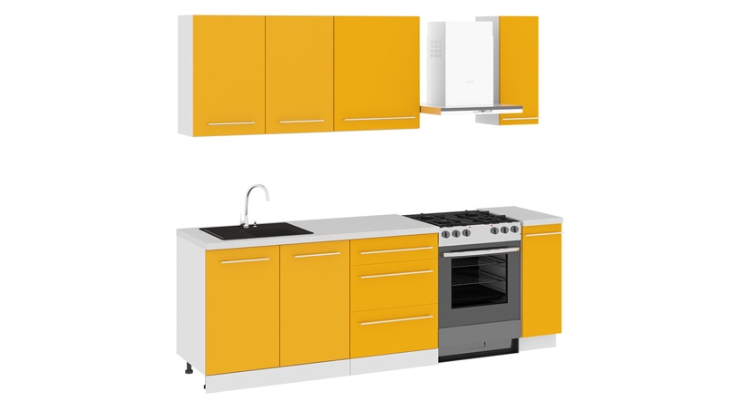 | - A: Is there a sink in the kitchen?  B: Yes, there is.  - A: … a cooker in the kitchen?  B: …  - A: … a vase in the kitchen?  B: …  - A: … any cupboards in the kitchen?  B: …  - A:…a washbasin in the kitchen?  B: …  - A: … any stairs in the kitchen?  B: …

Ex.3 Fill in there is/there are. (3*1=3 points)
- … not any books on the bedside table.
- … any pencils on the desk.
- … a chair in the kitchen.

Ex.4 Choose the correct word. (5*1=5 points)
- There are any/some/an books in the bookcase.  - There isn’t some/a/an armchair in the hall.  - Have you got an/a/some apple? | - Are there any/some/a notebooks in the schoolbag?  - John has got any/a/some pens on his desk.

Ex.5 Look at the picture and fill in the gaps with the correct preposition.
(5*1=5 points)
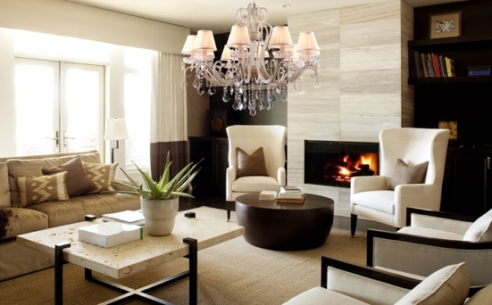 | There is a coffee table 0) in the living room. There is a vase 1) …the coffee table. The brown coffee table is 2)… two large sofas. 3)…the table is the fireplace. There is a bookcase 4)… the armchair. There is a carpet 5)… the coffee table.

Ex.6 Read the email. Answer the questions. (5*2=10 points)
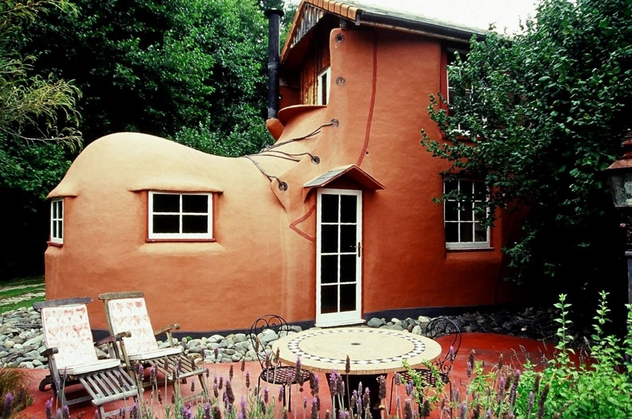  - Why is the house unusual?  - Where is it?  - How many levels are there?  - How many rooms has it got?  - What is there outside the house? | 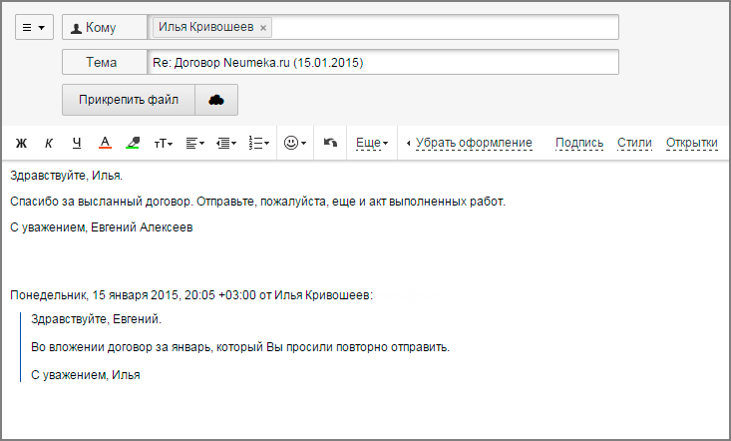  ChloeW2@gmail.com  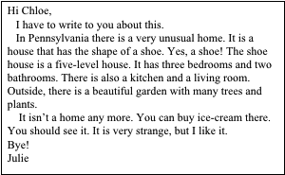  An unusual home!!
Ex.7 Listening. Listen and complete the gaps (1-5)
(5*2=10 points)
FOR SALE
House 200 m²

Inside: 1) …
bedrooms, two modern
2) …
Outside: big 3)…
and 4) …
Contact: 5) …
Tel: 202 463 789

54-46=”5”
45-35=”4”
34-27=”3”
26-0=”2”

