Test 5 Options-5
I variant
Ex.1 Vocabulary. Complete the pairs. (7*1=7 points)

- dad-  - son-  - cousin-  - husband- | - brother-  - uncle-  - granddad-

Ex.2 Choose the correct word. (5*1=5 points)
- Maria is so … sometimes. She acts like a child!  A silly B rude C weak  - Little Joseph is such a baby. He never cries.  A kind B weak C quiet  - Why are you always so …? You never laugh or smile!  A kind B serious C strong | - George can carry your suitcase. He is very … .  A strong B serious C weak  - My sister is very … . She plays loud music and talks on the phone all day!  A rude B noisy C funny

Ex.3 Guess! Write the jobs! (9*2=18 points)
 |  |  |  |  |  | 1
 |  | 3 |  | 2
4
 |  |  |  |  |  |  |  |  |  |  |  | 8
 |  |  |  |  | 6
 |  |  |  |  |  |  |  |  |  | 9
 |  |  |  | 7

5

- This person does people’s hair.  - This person works at school.  - This person plays football.  - This person flies planes.  - This person takes photographs. | - This person repairs cars.  - This person looks after sick people.  - This person types letters.  - This person looks after sick animals.

Ex.4 Look at the clock faces and write time, as in the example. (5*2=10 points)
- It’s half past four.

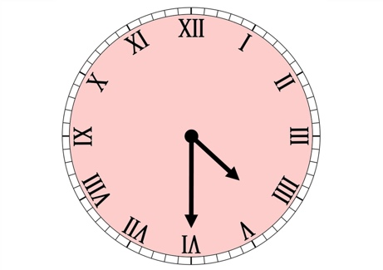

Grammar.
Ex.5 Fill in: don’t or doesn’t. (4*1=4 points)  - They …go out very often.  - Philip…play football well.  - My mum and I… know how to do it.  - I … watch TV in the morning. | Ex.6 Change the sentences into negative. (5*1=5 points)  - We go out every Sunday.  - My sister likes playing with dolls.  - His best friend runs very fast.  - They live in a big city.  - Our dad watch TV in the evening.

Ex.7 Write questions. (3*2=6 points)  - when/you/play/game/computer?  - what/we/have/for/breakfast/on/Mondays?  - where/they/go/at/weekends? | Ex.8 Fill in: do or does. Then answer the questions. (5*1=5 points)  - … you study French?  - … your friend play the guitar?  - … the parents go to the café?  - … we meet our friends after school?  - … your grandmother like meat? | X  V  V  X  V

Ex.9 Reading. Read the text below and answer the questions. (5*2=10 points)
My Favourite Day!
I am Stephen. My favourite day of the week is Saturday. On Saturdays I get up at 10:00 in the morning. I have a cup of tea, a piece of toast and a slice of cake. Then I go cycling in the park. I cycle for about an hour and then at noon I return home and have lunch. After lunch, I read a book or listen to music. In the afternoon I meet up with my friends. We usually go to the cinema or we stay at home and watch DVDs. I have dinner at around 8:30. After dinner, I practice the guitar. I go to bed at 11:00. I love Saturdays!

- What does Stephen have for breakfast?  - Where does Stephen go cycling?  - What does he do after lunch? | - What do Stephen and his friends usually do?  - When does Stephen go to bed?

70-60= «5»
59-46= «4»
45-35= «3»
34-0= «2»

