Test 6 Variant I (Options-7)
- Listen and complete the missing information. (3*5=15 points)
Bradford sports Centre
First name: 0) Hanry

Surname: 1)……

Age: 2)……

Sport: 3)…..

Date: 4) 20…..

Cost: 5) €……

- Look, read and choose. (6 points)
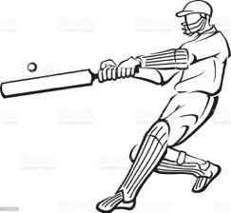1 | 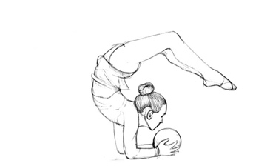2 | 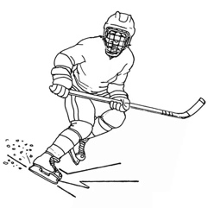 3
- Read and match. (6 points)
- hurt  - bruise  - break | - my leg  - an eye  - my back
- Read and fill in. (4*5=20 points)
Oh, no! I hope she’s alright! | No, I haven’t. | Sure! Count me in! | Yeah. Don’t worry!

- A: Have you ever tried judo?  B: …  - A: Are you sure this is a good idea?  B: … | - A: Would you like to play baseball?  B: …  - A: Jenny has hurt her back.  B: …
5. Make sentences. (3*1=3 points)
1. Johnny/ not finish/ his homework/ yet
2. you/ ever/ ride/ a horse
3. Donna/ never/ visit/ Wales

6. Read and circle. (3*2=6 points)
1. Fred has hurt/hurt his back last week.
2. Anna has cut/cut herself while she was making dinner.
3. Dad isn’t here. He’s been/gone to the supermarket.
7. Complete the sentences with the correct reflexive pronoun (myself, yourself, himself, herself, itself, ourselves, yourselves, themselves ). (3*1=3points)

- Alan made …a sandwich.
- I hurt …while I was skiing.
- Did they enjoy … at the cinema?
8. Read and choose. A, B or C. (15 points )
Dear Tony,
How’s it going? Hope you had a nice weekend. I’m writing to tell you what happened at my birthday party.
My birthday party was last Saturday. All of my friends came over and we had a great time. But guess what happened? My dog ran in and knocked over my birthday cake! As I was trying to catch the cake, I hit my head on the table and got a black eye! Then I fell on my cake! My sister took a picture of me, too – I look so silly with cake all over my head, but I really enjoyed it
I can’t wait to see you and tell you all about it and show you the picture!
See you soon,
Ryan

- Why is Ryan writing to Tony? | A to tell him about what happened at his birthday party | B to tell him about his sister’s birthday party | C to ask him to come to his birthday party
- What happened to Ryan? | A He hit the table. | B He knocked over his cake. | C He got a black eye.
- Who tried to catch the cake? | A Ryan | B Ryan’s sister | C Ryan’s friend

74-63=”5”
62-48=”4”
47-37=”3”
36-0=”2”

Test 6 Variant II (Options-7)
- Listen and complete the missing information. (3*5=15 points)
Bradford sports Centre
First name: 0) Hanry

Surname: 1)……

Age: 2)……

Sport: 3)…..

Date: 4) 20…..

Cost: 5) €……

- Look, read and choose. (6 points)
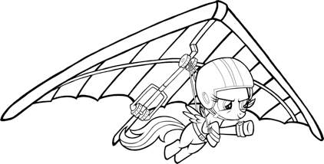1 | 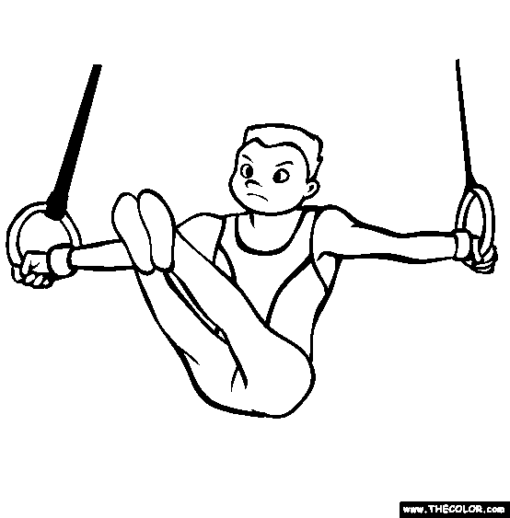 2 | 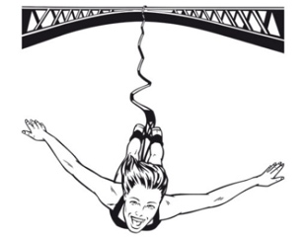 3
- Read and match. (6 points)
- burn  - twist  - hit | - my ankle  - my finger  - my head
- Read and fill in. (4*5=20 points)
Oh, no! I hope she’s alright! | No, I haven’t. | Sure! Count me in! | Yeah. Don’t worry!

- A: Are you sure this is a good idea?  B: …  - A: Have you ever tried judo?  B: … | - A: Jenny has hurt her back.  B: …  - A: Would you like to play baseball?  B: …
5. Make sentences. (3*1=3 points)
1. Patty/ just/ make/ lunch
2. Bob/ live here/ for/ ten years
3. She/ be/ a teacher/ since 2000
6. Read and circle. (3*2=6 points)
1. Ben has bought/bought a car in 2008.
2. Sue has been/gone to Madrid. She came back yesterday.
3. When has she called/did she call you?
7. Complete the sentences with the correct reflexive pronoun. (myself, yourself, himself, herself, itself, ourselves, yourselves, themselves ). (3*1=3points)
1. Billy burned… in the kitchen yesterday.
2. I can’t believe you made the cake …!
3. We organized the school play … .

8. Read and choose. A, B or C. (15 points )
Dear Tony,
How’s it going? Hope you had a nice weekend. I’m writing to tell you what happened at my birthday party.
My birthday party was last Saturday. All of my friends came over and we had a great time. But guess what happened? My dog ran in and knocked over my birthday cake! As I was trying to catch the cake, I hit my head on the table and got a black eye! Then I fell on my cake! My sister took a picture of me, too – I look so silly with cake all over my head, but I really enjoyed it
I can’t wait to see you and tell you all about it and show you the picture!
See you soon,
Ryan

- Who came to Ryan’s birthday party? | A his relatives | B his parents | C his friends
- What did Ryan try to catch? | A the dog | B the cake | C his sister
- How did Ryan feel about the party? | A tired | B silly | C happy

74-63=”5”
62-48=”4”
47-37=”3”
36-0=”2”

