Test 6 I variant (Options-5)
Ex. 1 Use the adjectives below to describe the animals.  •small •sharp •short •big •thick • long • thin  - Bears have .......... bodies and ...............fur.  - Giraffes have ..................... tails and necks.  - Cats have ........................................ claws. | Ex. 2 Choose the correct word(s).  - Eagles have got tall/sharp claws.  - Pink dolphins hunt/frighten for food alone.  - Koalas weigh/live about 10 kilos.  - A bear has got a thick/large body.  - A cow has got big horns/teeth.
Ex. 3 Choose the correct answer.  - School starts ........... 8:30. A at B on C in  - ..... do kangaroos live? In forests.  A Why B Where C How  - ..... time is it? Three o’clock.  A When B How C What  - .. brothers have you got? Two.  A How B How long C How many  - Max goes to the gym …. Monday.  A at B in C on | Ex. 4 Put the adverbs in the correct place.  - Alistair is late for school. (never)  - Tigers hunt at night. (usually)  - They order take-away food. (sometimes)
Ex. 5 Read the text and answer the questions.
Badgers (барсуки)
Badgers come from Europe, America and Asia. They have thick grey fur and always have white stripes on their head. They live in large burrows under the ground. They like to be with their family and they often play together. Badgers weigh about 10 kg. Badgers usually sleep all day. They come out at night to hunt for their food. They eat insects and plants. Badgers live for up to 14 years.
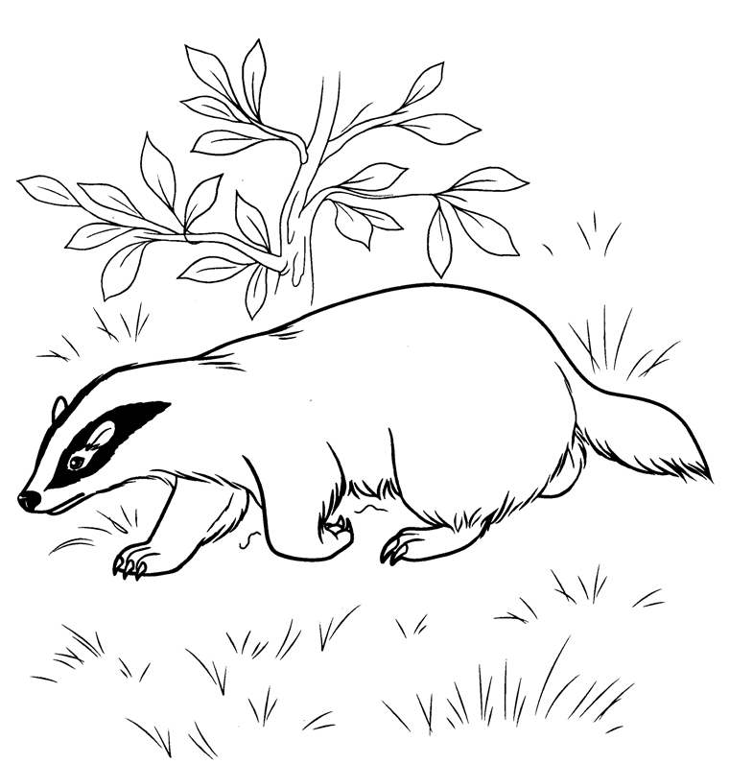
- What do they look like?
- Where do they live?
- How much do they weigh?
- When do they sleep and hunt?
- How long do they live?

Test 6 II variant (Options-5)
Ex. 1 Use the adjectives below to describe the animals.  •small •sharp •short •big •thick • long • thin  - Canaries have ................................. wings.  - Camels have long .............................. legs.  - Ducks have ....................................... legs. | Ex. 2 Choose the correct word(s).  - A crocodile has got a sharp scales/teeth.  - A giraffe has got a long body/neck.  - A dolphin has got fins/wings.  - An eagle has got a small/big beak.  - Bears eat/sleep in the winter.
Ex. 3 Choose the correct answer.  - Bears sleep ........... the winter. A at B on C in  - Her birthday is ........... 2nd January.  A at B on C in  - ........... are you? Not bad.  A How B What C Who  - ........... do pandas eat? Bamboo.  A When B What C Who  - .... do you go out? Every Sunday.  A Where B How often C What | Ex. 4 Put the adverbs in the correct place.  - Lisa takes the train to work. (often)  - Ben waters the plants in the morning. (always)  - Francis takes the dog for a walk in the afternoon. (usually)
Ex. 5 Read the text and answer the questions.
The Blue Peacock
The Blue Peacock comes from India and Sri Lanka. It is a national bird of India.
It has got a big body, long legs, a long neck and a small head. Its tail feathers are very long and beautiful. It has got wings but it can’t fly. It lives in gardens. Peacocks eat insects, plants, and small creatures. Peacocks weigh about 4-5 kg. Peacocks live for up to 14 years. It is a national bird of India.
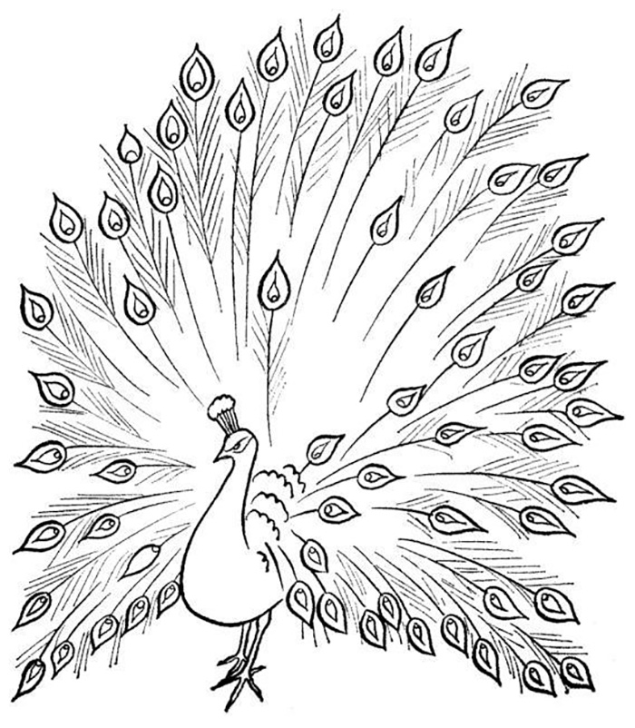
- What do they look like?
- Where is the Blue Peacock from?
- What can they do?
- How much do they weigh?
- What do they eat?

