Test 4 Options-5
I variant
Ex.1 Vocabulary. Do the crossword. (9*1=9 points)
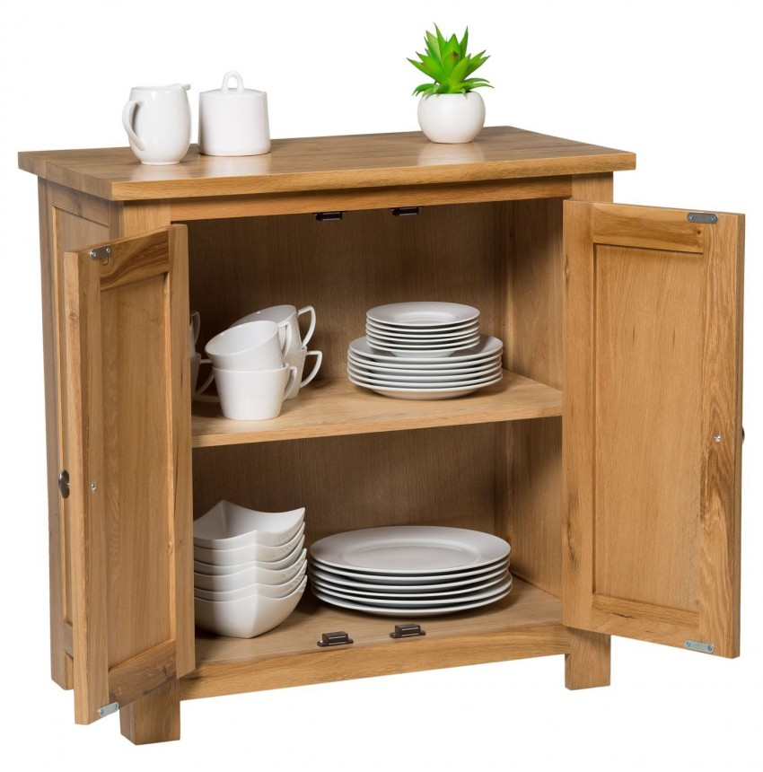
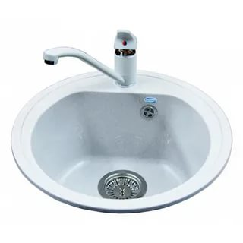

 |  |  |  |  |  |  |  |  |  |  | 3
1 |  |  |  | 2 |  |  |  |  |  | 4
 |  |  |  | 5
 | 6 | 7
 |  | 8
 | 9
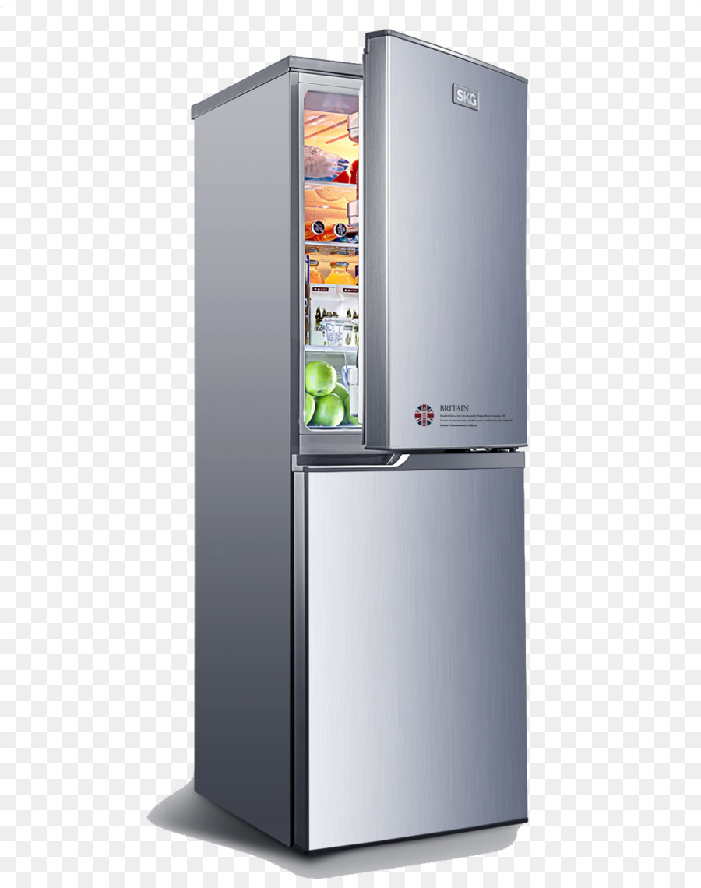

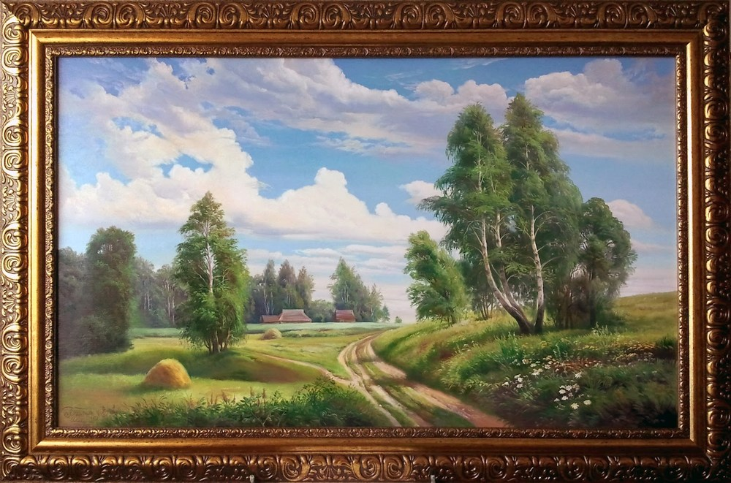

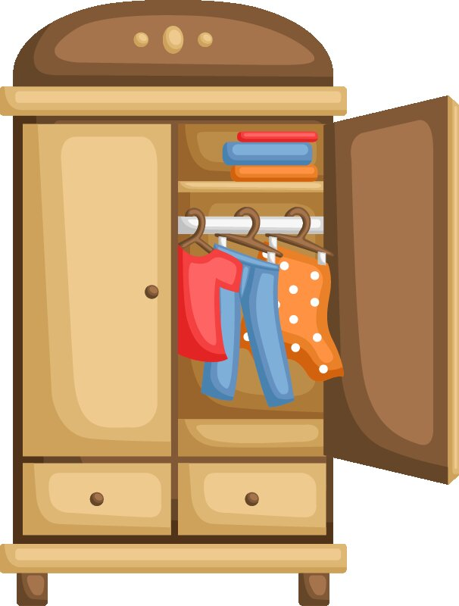

Ex.2 Grammar. Look at the picture. Complete the gaps with there is/there are. (6*2=12 points)
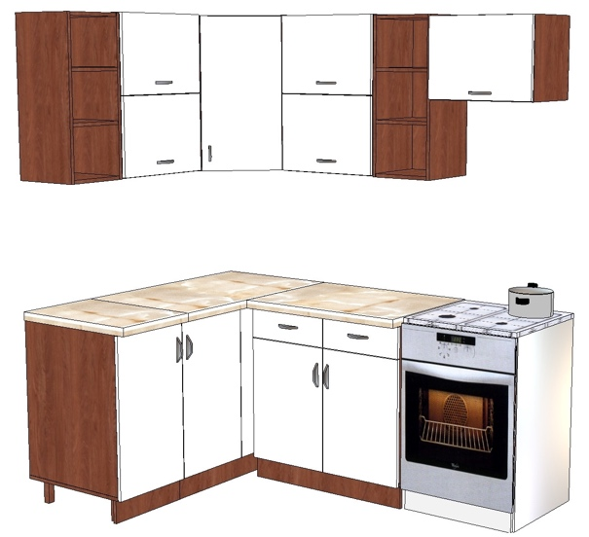 | - A: Is there a sink in the kitchen?  B: Yes, there is.  - A: … a cooker in the kitchen?  B: …  - A: … a vase in the kitchen?  B: …  - A: … any cupboards in the kitchen?  B: …  - A:…a washbasin in the kitchen?  B: …  - A: … any stairs in the kitchen?  B: …

Ex.3 Fill in There is/There are. (3*1=3 points)
- … an armchair in the living room.
- … two sofas in living room.
- … not a window in the bedroom.

Ex.4 Choose the correct word. (5*1=5 points)
- I haven’t got a/an/any eraser.  - Is there some/a/an window in the room?  - There aren’t an/some/any towels. | - Can I have some/any/a biscuit, please?  - We haven’t got any/some/a bananas.

Ex.5 Look at the picture and correct the prepositions. (5*1=5 points)
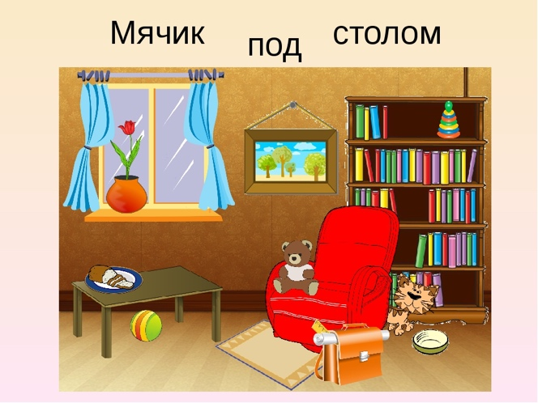 | - There is a ball next to the table.  - There is a cat on the armchair.  - There is a schoolbag under the armchair  - There is a teddy bear in the bookcase.  - There is a picture under the window and the bookcase.  - There is a bookcase next to the armchair.  - There is a vase next to the window.

Ex.6 Read the email. Answer the questions. (5*2=10 points)
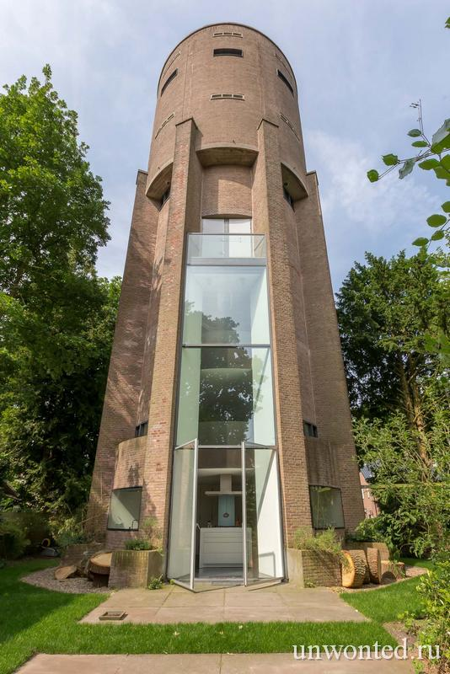 | 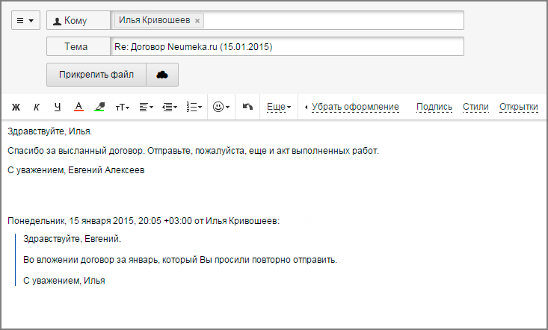  Hi Julie,  I have to write to you about this.  In Netherlands Holland there is a very unusual home. It is a house that has the shape of a water tower. Yes, a water tower! The house is a eight-floor house. It is 12 meters high. It has four bedrooms and three bathrooms. There is a kitchen on the first floor. The living room is on the second floor. Outside, there is a beautiful garden with many trees and plants. On the top there is a cozy terrace with beautiful views.  It is a real home. You can buy it now, it is sold for 950000 €. You should see it. It is very strange, but I like it.  Bye!  Ann  An unusual home!!  juilie@gmail.com

- Why is the house unusual?
- Where is it?
- How many floors are there?
- How many rooms has it got?
- What is there on the top of the house?

Ex.7 Listening. Listen and complete the gaps (1-5).
FOR SALE
House 200 m²

(5*2=10 points)

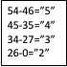

Inside: 1) …
bedrooms, two modern
2) …
Outside: big 3)…
and 4) …
Contact: 5) …
Tel: 202 463 789

