Test 6 Options-6
I variant
Ex. 1 Vocabulary. Read & write. (3*1=3 points)
1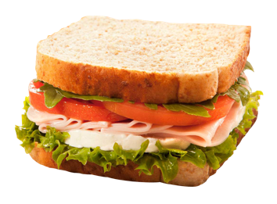 | 2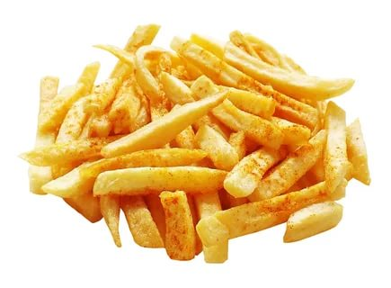 | 3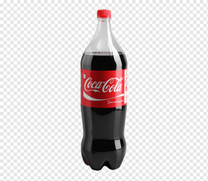

packet jar bars
Ex. 2 Read & complete the sentences. (3*3=9 points)
- Can I have a … of jam, please?
- How many … of chocolate do you have every week?
- Please buy a … of pasta from the supermarket.

Ex. 3 Grammar. Choose the correct answer. (5*1=5 points)
- Can I have … apple, please? A a B some C an
- Are there … eggs in the fridge? A any B some C much
- We don’t need … chocolate for the cake. A many B much C some
- How … cans of soup do you want? A much B any C many
- I’ve got … cherries. A a lot of B much C any
- There’s … rice on the plate. A a B some C any

Ex. 4 Read & underline the correct word. (3*2=6 points)
- Can/Must I have a sandwich, Mum?
- You must/mustn’t eat in the classroom.
- We can/must be quiet in the library.

Ex. 5 Communication. Read & choose. (3*2=6 points)
- A: Can I help you?  B: a) I’d like a burger, please.  b) I’ve got it!  2) A: Anything else?  B: a) What is it?  b) Can I have some water please? | 3) A: Would you like anything to drink?  B: a) A bottle of water, please.  b) Here you are.

Ex. 6 Reading & Writing. Read and complete the blog entry. (6*3=18 points)
I think my favourite 1) …is rise. I’m not joking! I eat rice nearly 2) … day. My favourite 3) … is rice with peas, carrots 4) … eggs, but I like all kinds of rice dishes.
My mum 5) … most delicious risotto and 6) … home-made sushi is fabulous! I also love rice pudding. Yum!

Jack,12

Ex. 7 Listening. Listen and tick (V) A, B or C. (3*5=15 points)
- Helen is making a
A banana cake.
B honey cake. V
C chocolate cake.
- What are they buying from the supermarket?
A eggs
B milk
C honey
- When are they making the cake?
A Friday
B Saturday
C Sunday
- What doesn’t Tony like?
A burgers
B pizza
C chips

53-62=”5”
40-52=”4”
31-39=”3”
0-30=”2”

Test 6 Options-6
II variant
Ex. 1 Vocabulary. Read & write. (3*1=3 points)
1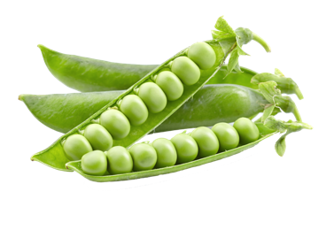 | 2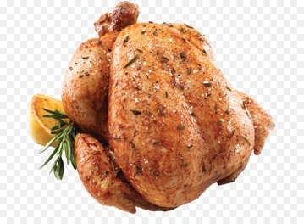 | 3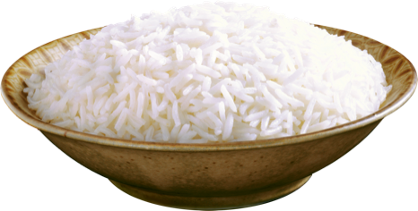

slice carton loaves
Ex. 2 Read & complete the sentences. (3*3=9 points)
- We need two … of bread for dinner.
- Joe drinks more than a … of juice every day.
- Would you like a … of pizza?

Ex. 3 Grammar. Choose the correct answer. (5*1=5 points)
- Can I have … apple, please? A a B some C an
- I’d like … orange, please A some B an C can
- There’s … butter in the fridge. A a lot of B a lot C any
- I haven’t got … cola. A some B many C any
- Can I have … carton of milk, please? A a B some C any
- How … bread do we need? A many B much C a lot

Ex. 4 Read & underline the correct word. (3*2=6 points)
- You can/must play outside if you want to.
- You can/must always do your homework.
- Can/Must you help me, please?

Ex. 5 Communication. Read & choose. (3*2=6 points)
- A: Can I play with my friends?  B: a) Hang on!  b) Yes, of course!  2) A: That’s £5, please.  B: a) Here you are.  b)They’re pounds. | 3) A: Can I use your computer?  B: a) Sorry, no.  b) Never mind!

Ex. 6 Reading & Writing. Read and complete the blog entry. (6*3=18 points)
I think my favourite 1) …is carrot. I’m not joking! I eat carrots nearly 2) … day. My favourite 3) … is carrot cake, chicken 4) … carrots and peas, but I like all kinds of carrot dishes.
My grandmother 5) … most delicious carrot soup and 6) … home-made salad is fabulous! Yum!
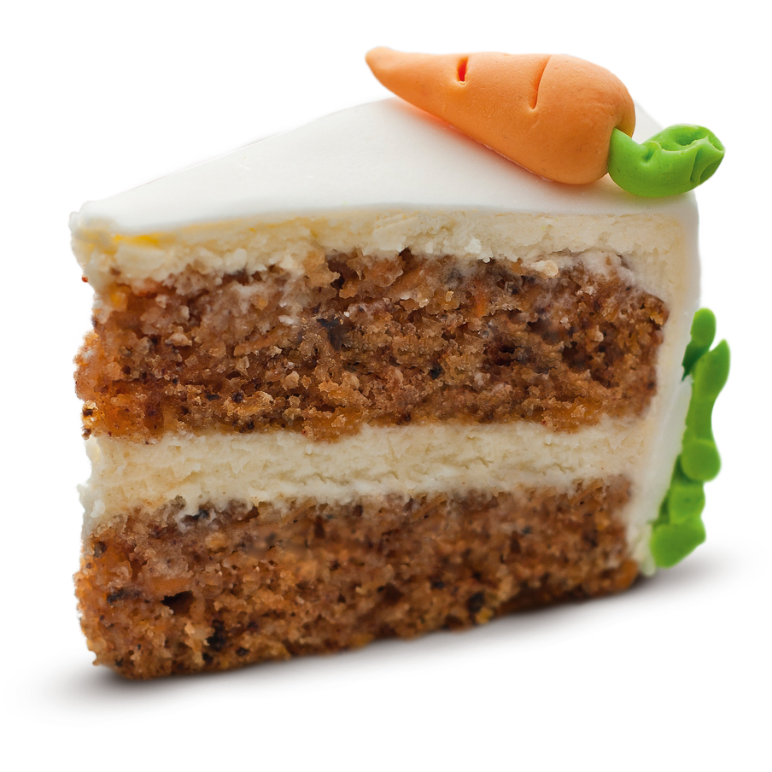

Mary,13

Ex. 7 Listening. Listen and tick (V) A, B or C. (3*5=15 points)
- Helen is making a
A banana cake.
B honey cake. V
C chocolate cake.
- What are they buying from the supermarket?
A honey
B eggs
C milk
- When are they making the cake?
A Sunday
B Saturday
C Friday
- What doesn’t Tony like?
A chips
B burgers
C pizza

53-62=”5”
40-52=”4”
31-39=”3”
0-30=”2”

Keys I variant
Ex. 1: 1) sandwich; 2) chips; 3) cola
Ex. 2: 1) jar; 2)bars; 3)packet;
Ex. 3: 1) A any; 2) B much; 3) C many; 4) A a lot of; 5) B some;
Ex. 4: 1) can; 2) mustn’t; 3) must;
Ex. 5: 1a; 2b; 3a;
Ex. 6: 1) food; 2) every; 3) dish; 4) and; 5) makes; 6) her;
Ex. 7: 1C; 2A; 3B;

Keys II variant
Ex. 1: 1) peas; 2) chicken; 3) rice;
Ex. 2: 1) loaves; 2) carton; 3) slice;
Ex. 3: 1) B an; 2) A a lot of; 3) C any; 4) B some; 5) B much;
Ex.4: 1) can; 2) must; 4 must;
Ex.5: 1) b; 2) a; 3) a;
Ex.6: 1) food; 2) every; 3) dish; 4) with; 5) makes; 6) her;
Ex.7: 1) A honey; 2) C Friday; 3) C pizza;

