Test 4 Options-6
I variant
Ex. 1 Look and choose.
- 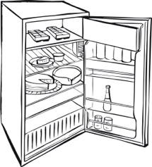  - cooker b) fridge | - 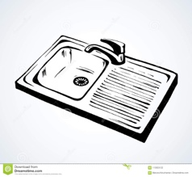  - mirror b) sink | - 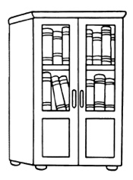  - bookcase b) desk  (3points)
Ex. 2 Complete. Use: in, on, under, behind, next to, in front of, between.
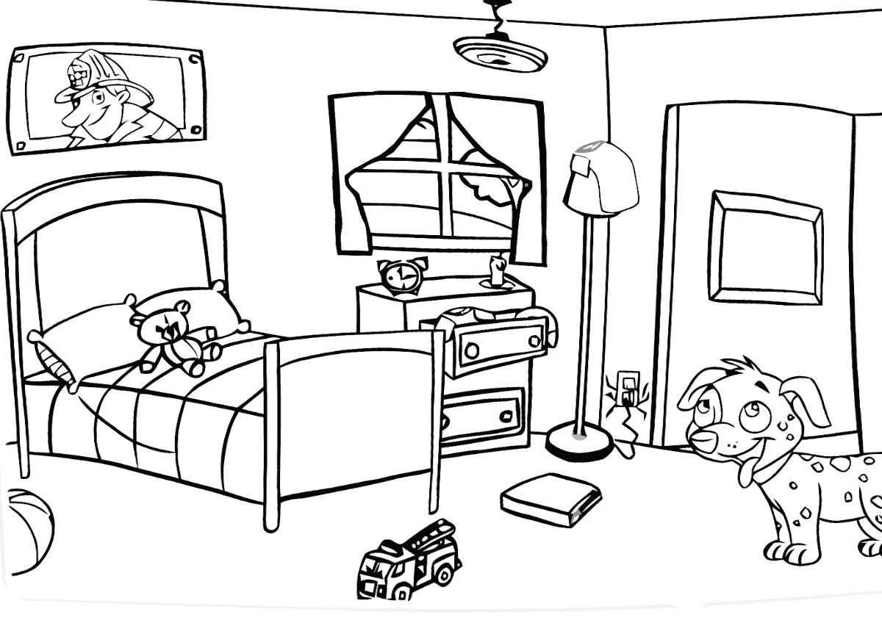 | This is my room. My bedside table is 1) … the bed and the lamp. There is a bed 2) … the bedside table. There are pillows 3) … my bed. Can you see my dog, Doggy. He is 4) … the door. There is a window 5) … the bedside table. There is a jacket 6) … the bedside table. There is a box 7) … the bed.  (7*2=14 points)
Ex. 3 Read and choose the correct answer.
- That’s Dave. Do you know____?  A us B you C him | - I love your new toys! ____ are in front of their new house.  A Them B They C We | - Do you want to play with ____?  A he B me C I  (3*2=6 points)
Ex. 4 Read Liz’s letter and write her the answer about your dream home. Liz’s questions will help you.
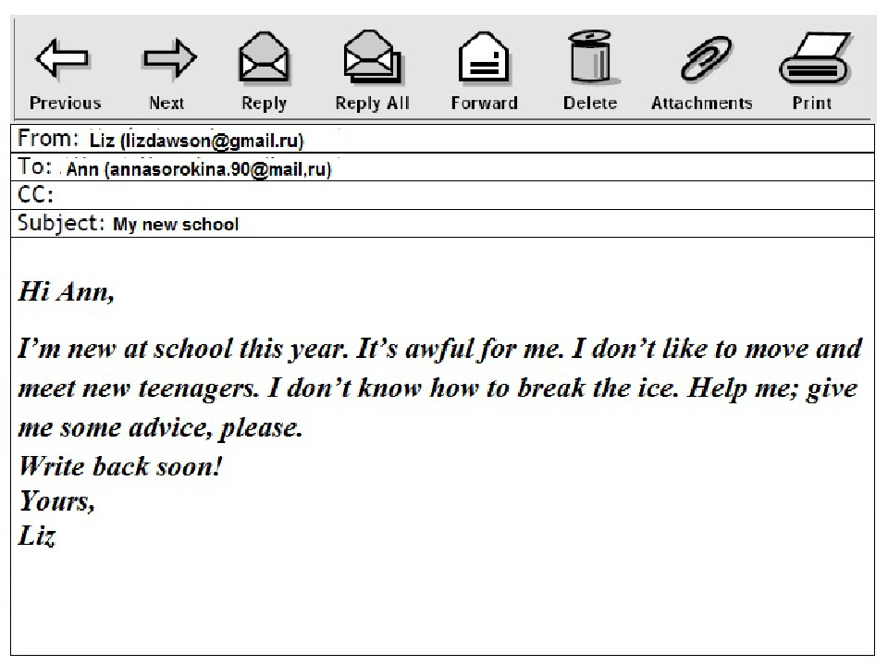
Hi …,
I’ve got a dream home. It is in Spain near the sea. It has got one floor and a huge pool.
There is a big living room, a modern kitchen, five bedrooms and four bathrooms. My favourite place is the pool. I love swimming.
My dream bedroom is very cool. Everything in it is red and pink! I’ve got a comfortable bed with lots of soft pillows, a wardrobe, a desk and a computer. I’ve also got a bathroom, just for me!
I like my dream home because it’s beautiful and there is a great view of the sea. It’s a fantastic home!
Write me about your dream home: Where is your dream home? What rooms has it got? Which is your favourite room? What colour is your dream bedroom? What is there in it? Why do you like your dream house?
Love,
Liz
My Dream home

(14 points)
Ex. 7 Listening. Mach the names with the person.
(10 points)

Totally 47 points

37-32=”5”
31-24=”4”
23-19=”3”
18-0=”2”
47-40=”5”
39-31=”4”
30-24=”3”
23-0=”2”
60-51=”5”
50-39=”4”
38-30=”3”
29-0=”2”

Test 4 Options-6 II variant
Ex. 1 Look and choose.
1)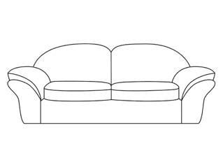  - sofa b) armchair | 2)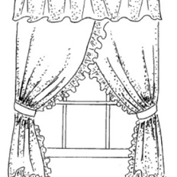  - carpet b) curtains | 3)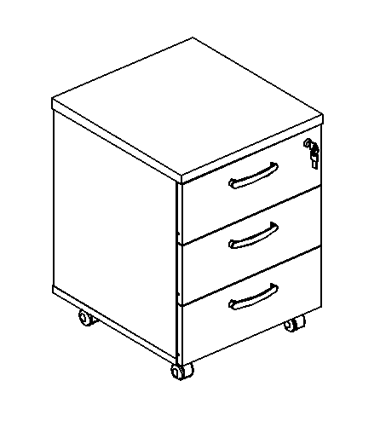  - bedside table b) lamp  (3points)
Ex. 2 Complete. Use: in, on, under, behind, next to, in front of, between.
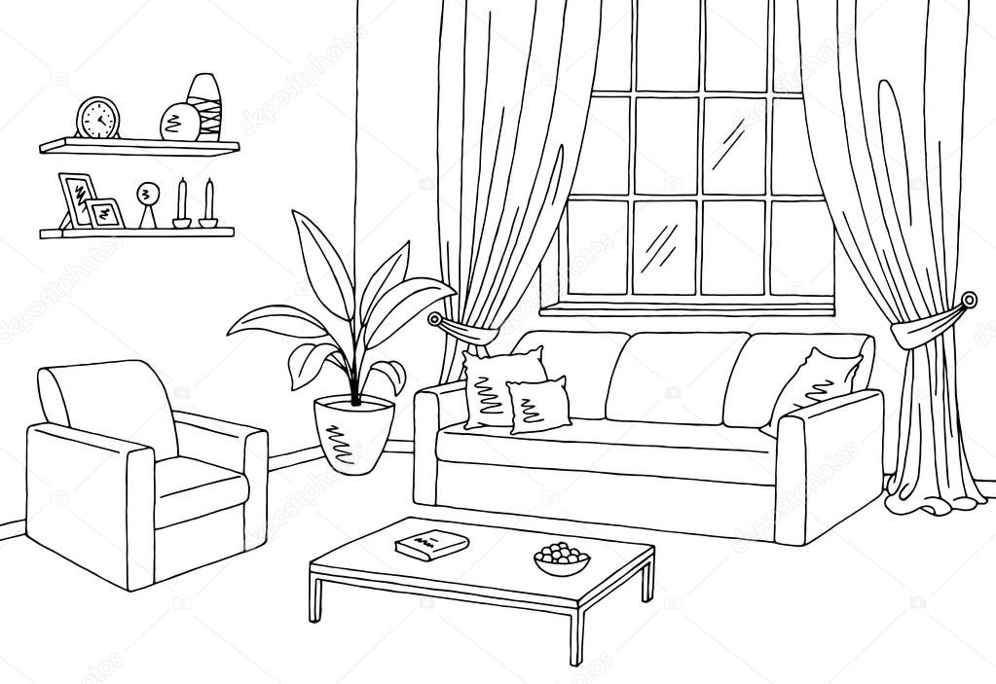 | This is our living room. There is a big window with some white curtains 1) … it. The window is 2) … the sofa. There is a coffee table 3) … the sofa. There’s a coffee table 4) … the armchair. There is a plant (растение) 5) … the armchair and the sofa. The armchair is 6) … the bookcase. The photos are 7) … the bookcase.  (7*2=14 points)
Ex. 3 Read and choose the correct answer.
- Can you help____with my homework?  A I B me C you | - Look at ____! They are in front of their new house.  A they B them C their | - Do you want to come with ____?  A we B us C he  (3*2=6 points)
Ex. 4 Read Liz’s letter and write her the answer about your dream home. Liz’s questions will help you.
My dream home

Hi …,
I’ve got a dream home. It is in Spain near the sea. It has got one floor and a huge pool.
There is a big living room, a modern kitchen, five bedrooms and four bathrooms. My favourite place is the pool. I love swimming.
My dream bedroom is very cool. Everything in it is red and pink! I’ve got a comfortable bed with lots of soft pillows, a wardrobe, a desk and a computer. I’ve also got a bathroom, just for me!
I like my dream home because it’s beautiful and there is a great view of the sea. It’s a fantastic home!
Write me about your dream home: Where is your dream home? What rooms has it got? Which is your favourite room? What colour is your dream bedroom? What is there in it? Why do you like your dream house?
Love,
Liz

(14 points)
Ex. 7 Listening. Mach the names with the person.
(10 points)

Totally 49 points
47-40=”5”
39-31=”4”
30-24=”3”
23-0=”2”
37-32=”5”
31-24=”4”
23-19=”3”
18-0=”2”

