Test 7 Options-6
I variant
Ex. 1 Vocabulary. Where were they yesterday? Match the pictures to the sentences. (3*2=6 points)
A | B | C
- Don was at the newsagent’s.
- Steve was at the pet shop.
- Brian was at the shopping centre.

Ex. 2: Write the musical instruments. (3*1=3 points)
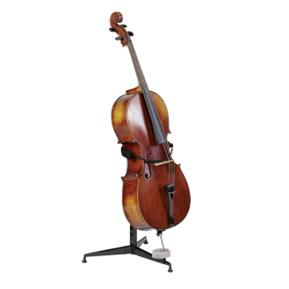  - loecl | - anpio | 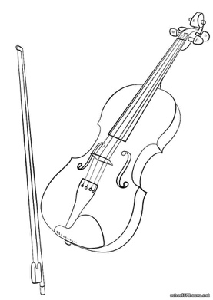  - lovnii

Ex. 3: Grammar. Complete the sentences. Use: was or were. (3*2=6 points)
- Harry … at the pet shop yesterday.
- Lou and Harry … at the concert last night.
- … your mother in Spain last month?

Ex. 4: Complete the sentences. Use the verbs in the Past Simple. (8*1=8 points)
- Patrick … me. (not/help)
- … Tracy at a hotel in Paris? (stay)
- Dad … football last Saturday. (play)
- Elvis Presley … in 1977. (die)
- We … TV last night. We played chess. (not/watch)
- … you … a pizza? (order)
- Shelley … to school. (not/walk)
- … they … the police. (call)

Ex. 5: Communication. Read and complete. Use: what, next, marine, anytime, dolphins, sounds. (5 points)
A: Hi, Frank. 0)… What was your weekend like?
B: It was amazing. I visited the 1) … park with parents.
A: Really? How was it?
B: It was fantastic! We watched a great show with some 2)… .
B: I bet! What else can you do there?
A: There’s a restaurant there. We ordered some chicken and pasta.
B: 3) … good.
A: It certainly was. We want to go again.
B: Can I come with you 4) … time?
A: Definitely. 5) … !

Ex. 6: Reading & Writing. Read the postcard and answer the questions. (6*3=18 points)
Hi Carla!  I’m writing to tell you all about SpaceZone in Canada. I was there with my cousin yesterday! It’s fantastic and there’s so much to see and do! I really loved the rides! My favourite one was Moonwalker! We also watched a show with some astronauts and |  | 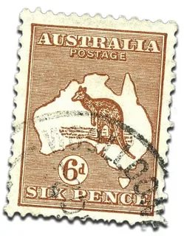
that was amazing, too. Then, we watched the parade with lots of | Carla White
alien characters including ET, Chewbacca and Spock. It was a | 13 Victoria | Street
great day! I’m sending you some photo! | Liverpool
Talk soon. | L25QA
Sharon | UK

- Where is SpaceZone? | A in Canada | B in China | C in the UK
- Who was Sharon there with? | A her cousin | B her sister | C her friend
- What was Sharon’s favourite ride? | A Sunbeamer | B Moonwalker | C SpaceZone
- Who performed in the show? | A pilots | B aliens | C ausronauts
- Who was in the parade? | A Al | B ET | C Sharon
- What is Sharon sending Carla? | A photos | B videos | C music

Ex. 7: Listening.
- Listen to six short dialogues. Match them to the pictures. (5*2=10 points)
A | B | 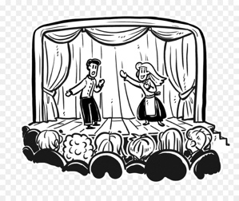  С
D | E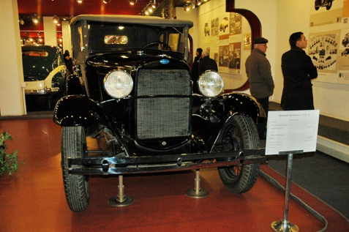 | F

Dialogue | 0 | 1 | 2 | 3 | 4 | 5
Picture | A

- Listen again and correct mistakes. (5*2=10 points)
Dialogue 0: Ronnie wants to touch feed the tigers.
Dialogue 1: The seat numbers are 4S and 5S.
Dialogue 2: Jane Dean wants to report a lost watch.
Dialogue 3: The name of the band is The Bad Boys.
Dialogue 4: Helen’s shoe size is 37.
Dialogue 5: It’ half past five.

