Test 5 Options-6
I variant
Ex.1 Vocabulary. Write the sports. (5*1=5 points)
1 | 2 | 3 | 4 | 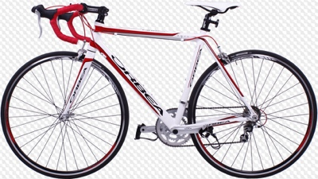  5
Ex.2 Read and complete the sentences. (6*1=6 points)
barbecue / magazine / present / meal / chess / Net
- Becky is in her room. She is reading a …. .  - He is busy. He is surfing the … .  - Sam is playing … with his dad in the living room. | - Sue is preparing a big … for tonight.  - I can’t wait to give Harry his birthday … !  - Dad’s getting the … ready for the party!
Ex.3 Grammar. Read and complete the sentences. Use Present Continuous. (3*2=6 points)
- Patrick … (sing) in the bathroom. Listen!
- … (they/have) a piano lesson tomorrow?
- What … (you/do) tonight?
Ex.4 Read and underline. (3*2=6 points)
- Judie eats/is eating sandwiches every morning.
- Stella doesn’t watch/isn’t watching TV right now.
- Are you coming/do you come to Roy’s party tomorrow night?
Ex.5 Communication. Read and complete. Use: want; do; can’t; love; going; mind; (5*2=10 points)
Tom: Hey, Liam. I’m going to the park tomorrow. Do you want to come?
Liam: I’d 1)… to, thanks. What time are you going?
Tom: At about ten.
Liam: That’s fine.
Tom: How about 2) … to Burger World after the park?
Liam: I’m afraid I 3) … .
Tom: That’s a shame!
Liam: Never 4) … . We can 5) … it another time!
Ex.6 Reading & Writing. Read, choose and complete. (6*3=18 points)
Hi Mary,

How are things? I’m going to a hockey match 1) … Saturday. 2)… anything then? Do you want to come?

The hockey match is on Sports Arena. We are playing against Hill School! After the match, we can go 3) … a pizza! My mum 4)… this Saturday, so she can drive us there 5)… we can take the bus, if you like. It starts at four o’clock and the tickets 6) … 5$. We are leaving at about three. I’m taking my camera with me because I want to take some pictures so bring your camera, too!

I hope you can come, but let me know if you can’t.

Love,
Sue
1 | A on | B at | C in
2 | A Do you do | B Are you doing | C You are doing
3 | A to | B in | C for
4 | A isn’t working | B doesn’t work | C aren’t working
5 | A and | B so | C or
6 | A cost | B costs | C are costing

Ex.7 Listening. Listen & tick (v) the correct answer. (5*3=15 points)
0 What is Billy doing at the moment?
a | b | c
1 What is Danny doing next Sunday?
a | b | c
2 Which is Becky’s favourite activity?
a | b | c
3 What does Sally do every day after school?
a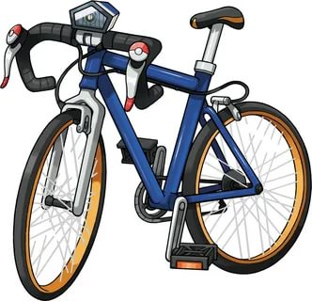 | b | c
4 What time is the hockey match?
a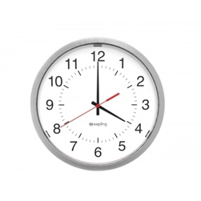 | b | c
5 How much is the ticket for the match?
a £ 4 | b £ 3 | c £ 1

Test 5 Options-6
II variant
- Ex.1 Vocabulary. Write the sports. (5*1=5 points)
1 | 2 | 3 | 4 | 5
Ex.2 Read and complete the sentences. (6*1=6 points)
flowers / fireworks / parade / phone / decorate / DVD
- We’re setting off the … tonight!  - Let’s … the house with lanterns!  - Are you watching the street … ? | - Let’s watch a … before we go to bed!  - She’s talking on the … .  - My grandma is in the garden. She’s planting some … .
Ex.3 Grammar. Read and complete the sentences. Use Present Continuous. (3*2=6 points)
- He … (not/take) the bus to school today.
- Why … (she/run)?
- They … (listen) to music.
Ex.4 Read and underline. (3*2=6 points)
- How often is he going/does he go to the cinema?
- I always go/am going cycling at the weekends.
- My friend visits/is visiting me this weekend.
Ex.5 Communication. Read and complete.
Use: fancy; Why don’t we; fine; sounds; going; (5*2=10 points)
Becky: Hello.
Ron: Hi, Becky, it’s Ron here. Where are you?
Becky: I’m at home. Why?
Ron: I’m 1)… to the park, do you 2) … going with me?
Becky: That 3) … good! What time are you going?
Ron: At 5 o’clock.
Becky: That’s perfect!
Ron: 4) … we meet near the school?
Becky: That’s 5) … . See you.
Ron: Bye!
Ex.6 Reading & Writing. Read, choose and complete. (5*3=15 points)
Hi Mary,
How are things? I’m going to a hockey match 1) … Saturday. 2)… anything then? Do you want to come?

The hockey match is on Sports Arena. We are playing against Hill School! After the match, we can go 3) … a pizza! My mum 4)… this Saturday, so she can drive us there 5)… we can take the bus, if you like. It starts at four o’clock and the tickets 6) … 5$. We are leaving at about three. I’m taking my camera with me because I want to take some pictures so bring your camera, too!
I hope you can come, but let me know if you can’t.
Love,
Sue
1 | A at | B on | C in
2 | A Are you doing | B Do you do | C You are doing
3 | A for | B in | C to
4 | A doesn’t work | B isn’t working | C aren’t working
5 | A and | B or | C so
6 | A are costing | B costs | C cost

Ex.7 Listening. Listen & tick (v) the correct answer. (5*3=15 points)
0 What is Billy doing at the moment?
a | b | c
1 What is Danny doing next Sunday?
a | b | c
2 Which is Becky’s favourite activity?
a | b | c
3 What does Sally do every day after school?
a | b | c
4 What time is the hockey match?
a | b | c
5 How much is the ticket for the match?
a £ 1 | b £ 4 | c £ 3

Keys I variant
Ex. 1 1) volleyball; 2) golf; 3) badminton; 4) ice skating; 5) cycling ; (5*1=5 points)
Ex. 2 1) magazine; 2) Net; 3) chess; 4) meal; 5) present; 6) barbecue; (6*1=6 points)
Ex. 3 1) is singing; 2) Are they having; 3) are you doing; (3*2=6 points)
Ex.4 1) is eating; 2) isn’t watching; 3) Are you coming; (3*2=6 points)
Ex.5: 1)love; 2)going; 3)can’t; 4)mind; 5)do; (5*2=10 points)
Ex.6 1)on; 2) Are you doing; 3) for; 4) isn’t working; 5) or; 6) cost. (6*3=18 points)
Ex.7 1)B; 2)A; 3)C; 4)B; 5)A; (5*3=15 points)

Keys II variant
Ex. 1 1) athletics; 2) hockey; 3) table tennis; 4) sailing; 5) climbing; (5*1=5 points)
Ex. 2 1) fireworks; 2) decorate; 3) parade; 4) DVD; 5) phone; 6) flowers; (6*1=6 points)
Ex. 3 1) isn’t taking; 2) is she running; 3) are listening; (3*2=6 points)
Ex.4 1) does he go; 2) go; 3) is visiting; (3*2=6 points)
Ex.5 1) going; 2) fancy; 3) sounds; 4) Why don’t we; 5) fine; (5*2=10 points)
Ex.6 1)B on; 2)A Are you doing; 3)A for; 4)B isn’t working; 5)B or; 6)C cost. (6*3=18 points)
Ex.7 1)C; 2)C; 3)A; 4)A; 5)B; (5*3=15 points)

