Test 7 Variant I (Options-7)
Ex. 1. Listen and tick (V) A, B or C. (20 points)
- Where is the club?
A | Apple Road
B | King Street
C | Bing Street
- What does the club do?
A | It cleans up schools
B | It helps kids with their homework.
C | It arranges clean-up campaigns with schools.
- To be a member you have to pay
A | £20 a year.
B | £6 a year.
C | £15 a year.
- What do new members get?
A | a newsletter
B | a poster
C | a website

Ex. 2. Look and write. (9 points)
- 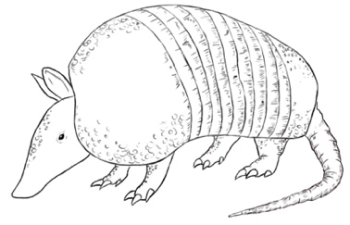
Ex. 3. Read and underline the right word. (3 points)
- He lives on a small island/valley off the coast of Scotland.
- Bats live in hills/caves.
- Angel Falls is the tallest waterfall/beach in the world.
Ex. 4. Read and choose. (10 points)
A must | B mustn’t
- A teacher … be kind and patient.
A may | B should
- You … take your dog to the vet if it’s ill.
A have | B could
- Nurses … to wear a uniform.

A that | B where
- This is the beach … we organized a clean-up campaign.
A can | B could
- I … swim when I was six.

Ex. 5. Put the adjectives in brackets in the correct form ( -ed or -ing). (6 points)
- I don’t like Art; It’s so … . (bore)
- I didn’t know Greg was … (interest) in working at the zoo.
- It’s so … (annoy) when people shout.

Ex. 6. Read and match. (5 points)
1 The whale’s stuck!  2 Let’s ask Tina to join in.  3 Should we take part?  4 Grandpa is lonely.  5 They’re going to clean up the part. | a It’s about time!  b Poor thing!  c Great idea!  d Of course we should.  e We should get him a dog.

Ex. 7. Read and write T (true) or F (false). (15 points)
Danny’s Blog May 5th
Hey, guys! I have just come back from an amazing holiday! Let me tell you about a really cool landmark I visited the Statue of Liberty, in New York City.
The Statue of Liberty is a beautiful statue that’s over 100 years old. It was a gift from the
people of France to the United States.
There is lots to do and see there. You can walk all the way up to the crown and take pictures.
But you have to be very fit, because there are 354 steps to reach the top! There is also a
museum inside the statue where you can see photographs and videos.
Well, better go now! What about you, bloggers? What famous landmark is there in your
country?

- Danny is going on holiday.
- The Statue of Liberty was a gift to the people of France.
- Visitors can walk up to the top of the statue.

68 – 58= “5”
57- 44= “4”
43- 34= ‘’3”
33-0= ‘’2”

Test 7 Variant II (Options-7)
Ex. 1. Listen and tick (V) A, B or C. (20 points)
- Where is the club?
A | Bing Street
B | Apple Road
C | King Street
- What does the club do?
A | It arranges clean-up campaigns with schools.
B | It helps kids with their homework.
C | It cleans up schools
- To be a member you have to pay
A | £6 a year.
B | £20 a year.
C | £15 a year.
- What do new members get?
A | a poster
B | a website
C | a newsletter

Ex. 2. Look and write. (9 points)
- 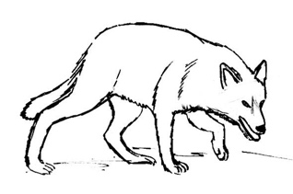 |  | - 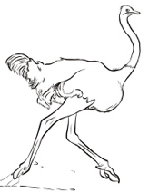
Ex. 3. Read and underline the right word. (3 points)
- Mt Fuji is an active volcano/cliff in Japan.
- There were a lot of tourists sunbathing on the valley/beach.
- We stood on top of the cave/cliff and looked out to sea.
Ex. 4. Read and choose. (10 points)
A which | B where
- This is the book… I bought yesterday.
A may | B must
- Sam… become a zookeeper, but he’s not sure yet.
A which | B who
- A historian is a person… studies history.

A that | B who
- Dolphins are animals… communicate with each other.
A can’t | B shouldn’t
- We … use mobile phones at the lessons.

Ex. 5. Put the adjectives in brackets in the correct form ( -ed or -ing). (6 points)
- I’m so … (embarrass) ! I forgot Ted’s birthday today!
- This book is really … (excite)! I can’t wait to finish it!
- Did you have a … (relax) summer holiday?

Ex. 6. Read and match. (5 points)
1 Grandpa is lonely.  2 Should we take part?  3 Let’s ask Tina to join in.  4 They’re going to clean up the part.  5 The whale’s stuck! | a We should get him a dog.  b Poor thing!  c It’s about time!  d Of course we should.  e Great idea!

Ex. 7. Read and write T (true) or F (false). (15 points)
Danny’s Blog May 5th
Hey, guys! I have just come back from an amazing holiday! Let me tell you about a really cool landmark I visited the Statue of Liberty, in New York City.
The Statue of Liberty is a beautiful statue that’s over 100 years old. It was a gift from the
people of France to the United States.
There is lots to do and see there. You can walk all the way up to the crown and take pictures.
But you have to be very fit, because there are 354 steps to reach the top! There is also a
museum inside the statue where you can see photographs and videos.
Well, better go now! What about you, bloggers? What famous landmark is there in your
country?
- Danny has come from the UK.
- The Statue of Liberty was a gift to the American people.
- There are over 300 steps inside.
68 – 58= “5”
57- 44= “4”
43- 34= ‘’3”
33-0= ‘’2”

