Test 5 I variant (Options-5)
Ex.1 Write the jobs.
1  3 2  4  5  5 points | 1 4  2 5  3

Ex.2 Fill in with the appropriate verb from the list. One word is extra.
• go • have • do • meet • watch •  1. On Sundays I usually .................. breakfast at 10:00.  2. Jane .............. her friends in the afternoon. | 3. Peter ............................. to school at 9:00.  4. I ................... my homework in the library.  .  4 points

Ex.3 Complete the dialogue. One sentence doesn’t match.
A And what time does it finish?
B When is it open?
C What time does the film start?
D Let’s meet outside the cinema.
Tony: Hello, Bill.
Bill: Hi, Tony. Are you free tonight?
Tony: Yes, I am.
Bill: Do you want to go the cinema?
Tony: 1) .............................................................
Bill: At 6:00.
Tony: 2) .............................................................
Bill: At 8:30.
Tony: That’s OK with me.
Bill: Can we meet at 5:30?
Tony: Yes, that’s fine.
Bill: 3) .............................................................
Tony: OK! See you there. 6 points

Ex.4 Read Derek’s letter. Use the words below to complete the sentences.
• husband • cousin • daughter • mum • granddad • brother • dad • aunt • grandma • family
Dear Harry,
I am Derek O’Sullivan and I am 14 years old. This is a picture of my 1)..................... . My 2)............... is Valerie. She is 40 years old and very friendly and kind. She can speak two languages, English and French. Patrick is my 3).................... . He is 41 and a lovely person. My 4).......................... is Peter. He is 78 and very funny. He is my mother’s father. Miriam is my 5)........................... . She’s 76 and she is a wonderful lady. Adam is my little 6)............................ . He is 5 years old and very clever. My 7).........................., Mary Kate, is my father’s sister. Her 8)........................... John is a famous pianist. Their 9).............................., Chloe, is ten years old and she is my favourite 10)...................................... .
Have you got a big family?
Please, send a picture!
Take care, Derek 10 points
Ex.5 Write questions and short answers as in the example.  0. you / study / English? (X) Do you study English? No, I don’t.  1. your father / work / as a teacher? (V)  2. your grandparents / live / with you? (V) | 3. your parents /go /to the gym? (X)  4. your friend /play /the guitar? (X)  5. you / meet / your friends after school? (V)  5 points

Total: 30 points
Ex.6 Look at the clock faces and write the time, as in the example. (You may Use: o’clock; half; quarter; past; to)
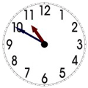  - It’s ten to eleven. |  | 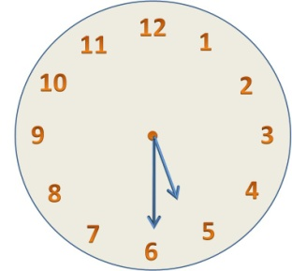  2.
3. | 4. | 5.

