«Знаю ли я Великобританию».
Quizzing game
Детям предлагается ряд вопросов. За правильный ответ присуждается 2 балла, за неполный – 1 балл. За неправильный – 0 баллов.
- [Slide 1]
Good afternoon!
I am glad to see you at our «Quizzing game».
You have got already information about Great Britain: its people, customs, traditions, way of life, sights. We have read books, watched films. Before we start our quiz you should give the official name of the country which is called Great Britain. [Slide 2]
- [Slide 3] You can see all 4 parts of The United Kingdom of Great Britain and Northern Ireland on the map. The capital of England is London. What are the capitals of other parts?
- [Slide 4] There are emblems of parts of the UK. Mach them.
A red rose is the national emblem of England from the time of the Wars of the Roses (15th century).
As a national emblem of Scotland, thistle apparently first used in the 15th century as a symbol of defence.
The national emblem of Ireland is shamrock.
A yellow daffodil or a leek pinned to their jackets, are national emblems of Wales.
- [Slide 5] Watch the film about Britain. Answer the questions about England.
- How many people live in England? ( 49 million people)
- How many people live in London? (7 million people)
- Where does the Prime Minister live? (10 Downing Street.)
- Where does the Queen live? (Buckingham Palace.)
- What is Stratford-upon-Avon famous for? (A birth place of William Shakespeare.)
- What is Liverpool famous for? (an important port and the home of The Beatles)
- Name two famous universities in England. (Oxford, Cambridge)
- Lets sow your visit cards.
- [Slide 6] Each country has its own flag. So the UK does. Let`s speak about British flag.
[Slide 7] You are given the information about British flag. Translate it in English, please.
(раздаются листочки для перевода каждой команде и даётся время для перевода и презентации.)
- [Slide 8] There is another important cymbal of this country. Have you guessed, who is she?
- We can recognize the country not only due to its flag, but due to its sights.
Read short text about castles and name them. [Slide 9] Check up! [Slide 10]
(выданные тексты: )

Malahide Castle is north-  east of Dublin City, Ireland,  and dates back to the 12th  century. It is in the middle of а large park and was used as both а fortress and а family home. It is а spooky place because people often see ghosts there. | Edinburgh Castle is Scotland's most famous castle. It is very popular with tourists and around 1 million people visit it every уеаr. It is а very unique castle as it was  built оn top of аn extinct volcano. | The Tower of London sits оn the banks of the River Thames. The Tower is guarded bу Yеоmаn Warders, оr 'Beefeaters'. Eight  big, black birds called ravens live in the Tower. There's а legend that says if they ever fly away, the  Tower will fall down. | Conwy Castle in Gwynedd, Wales, is а classical 13th century  fortress. It is а masterpiece of medieval architecture that took seven years to build. It has eight big towers that offer great  views of the nеаrbу river and the Snowdonian mountains.
- [Slide 11] Here you can see other sightseeing places of Britain. Can you recognize them?
- [Slide 12]Let`s name as many sightseeing places as possible. (даётся время)
- Westminster Abbey ;
- Buckingham palace ;
- National gallery ;
- Madame Tussauds's museum ;
- planetarium ;
- Stonehendge ;
- Pikadilli-Syorkus Square ;
- Tower bridge ;
- Cathedral of Saint Pavel ;
- [Slide 13] Britain is not only rich by its sightseeing places, but by its writers.
- Who wrote the books about the teddy bear Winnie-the-Pooh? (Alan Alexander Milne )

- What book did this picture come from? (Gulliver's Travels by Jonathan Swift)
- Where did this chest come from? (Treasure Island by Robert Louis Stevenson)
- The English author known as the Queen of Crime.? (Agatha Christie)
- Who wrote Oliver Twist ?( Charles Dickens)
- Where did this character come from? (The Jungle Book, Mowgli, Joseph Rudyard Kipling)
- Who is he? (((Lewis Carroll)
- What novel did they come from? (The Lord of the Rings. By J. R. R. Tolkien)
- Listen to the extract from the book (what book is it? Who is the author?) ("The Canterville Ghost" is a popular short story by Oscar Wilde,)
- Who lived in Sherwood Forest?( Robin Hood)
- [Slide 14] Read English proverbs and find the equivalent. [Slide 15] Check up.
- [Slide 16] Blitz quiz: Complete the sentences.
- Identify these famous British people, events and places. (даётся время и вопросы)

1. His monument stands in the centre of
Trafalgar Square. (Horatio Nelson, 1st Viscount Nelson,)
2. Here many famous Englishmen are buried. (Westminster Abbey)
3. The Crown jewels are kept here. (Tower of London)
4. The name Julius Caesar gave to Great Britain. (Albion.)
5. A traditional rowing race between 2 universities. (The Oxford and Cambridge Boat Race.)
6. A famous picture house in Trafalgar Square. (The National Gallery.)
7.This lady was the queen of Great Britain in 1831-1911. (Queen Victoria.)
8. The English author known as the Queen of crime.
Подводятся итоги. Вручаются грамоты победителям. Исполняется шотландская народная песня «My Bonny is over the ocean.»

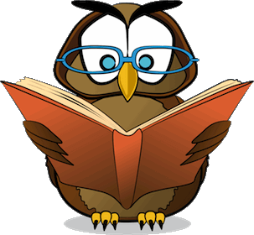 | Diploma | 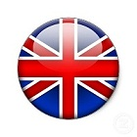

This is to certify that the team
«TOURISTS FROM IRELAND»
Has successfully completed the quiz
«How I know Great Britain»
Got____points
And is certified as a good English learner.
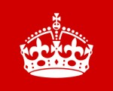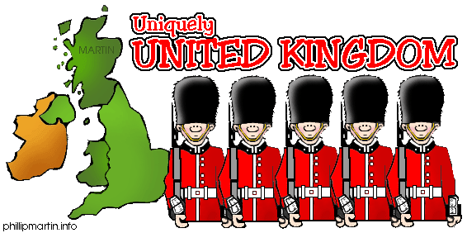

17.04.14 Head master of lyceum 144 /Князева В.В./

