Test 5 Options-5
II variant
Ex.1 Vocabulary. Complete the pairs. (7*1=7 points)
- wife-  - sister-  - niece-  - mother - | - daughter-  - grandmother-  - aunt-

Ex.2 Choose the correct word. (5*1=5 points)
- Karen is very … . She makes everyone laugh!  A kind B funny C rude  - Paul never says please and thank you. He is so … .  A rude B polite C noisy  - My grandma is very … . She helps and cares everyone in the family.  A weak B serious C kind | - Mark is very … . He can carry heavy things.  A strong B weak C clever  - Philippa is very … . She is the best student in the class.  A funny B quiet C clever

Ex.3 Write the jobs! (9*2=18 points)
 |  |  |  |  |  | 1
 |  | 3 |  | 2
4
 |  |  |  |  |  |  |  |  |  |  |  | 8
 |  |  |  |  | 6
 |  |  |  |  |  |  |  |  |  | 9
 |  |  |  | 7

5

- This person does people’s hair.  - This person works at school.  - This person plays football.  - This person flies planes.  - This person takes photographs. | - This person repairs cars.  - This person looks after sick people.  - This person types letters.  - This person looks after sick animals.

Ex.4 Look at the clock faces and write time, as in the example. (5*2=10 points)
- It’s half past four.  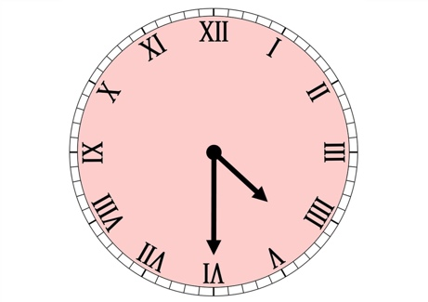 |  | - 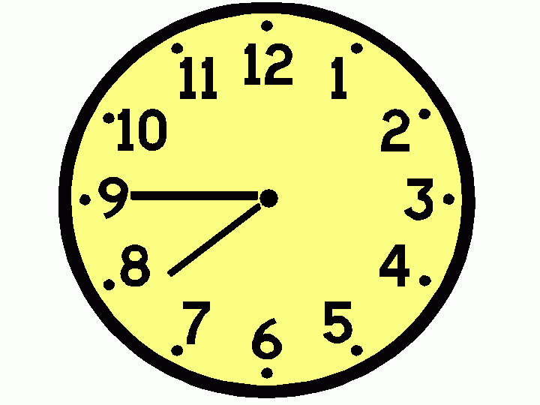

Grammar.
Ex.5 Fill in: don’t or doesn’t. (4*1=4 points)  - Dan …live in New York.  - We …go to school on Sundays.  - I… have breakfast at home.  - My friend … take the bus to school. | Ex.6 Change the sentences into negative. (5*1=5 points)  - My mother gets up early.  - Our dad goes to work by bus.  - We like fish.  - Kate and Ann play all day long.  - Georg has tea for breakfast.

Ex.7 Write questions. (3*2=6 points)  - where/you/go/after/school?  - what/she/do/on/Sundays?  - when/we/go/to/the/cinema? | Ex.8 Fill in: do or does. Then answer the questions. (5*1=5 points)  - … your elder brother live with you?  - … we have lessons on Saturday?  - … you like watching TV?  - … your friends walk to school?  - … our teacher live next to the metro? | X  V  V  X  V

Ex.9 Reading. Read the text below and answer the questions. (5*2=10 points)
My Favourite Day!
I am Stephen. My favourite day of the week is Saturday. On Saturdays I get up at 10:00 in the morning. I have a cup of tea, a piece of toast and a slice of cake. Then I go cycling in the park. I cycle for about an hour and then at noon I return home and have lunch. After lunch, I read a book or listen to music. In the afternoon I meet up with my friends. We usually go to the cinema or we stay at home and watch DVDs. I have dinner at around 8:30. After dinner, I practice the guitar. I go to bed at 11:00. I love Saturdays!

- What time does Stephen get up on Saturday morning?  - Why does he go to the park in the morning?  - Where does Stephen have lunch? | - What does he do after lunch?  - When does Stephen meet up with his friends?
70-60= «5»
59-46= «4»
45-35= «3»
34-0= «2»

