Test 5 Variant I (Options-7)
- Listen and put a tick(v). (3*5=15 points)
- Where are Larry and Kelly going for dinner? | Alfredo’s  A - V | At Pesto  B | At Nesto  C
- How far is the restaurant? | 10 km  A | 4 km  B | 1 km  C
- How much did Peter pay for the steak? | € 40  A | € 100  B | € 50  C
- Which food does Kim like? | 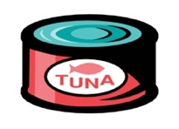 | 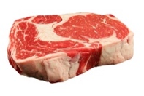 | 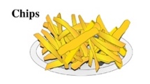
 | A | B | C
- Title the items. (3 points)
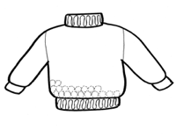 1 | 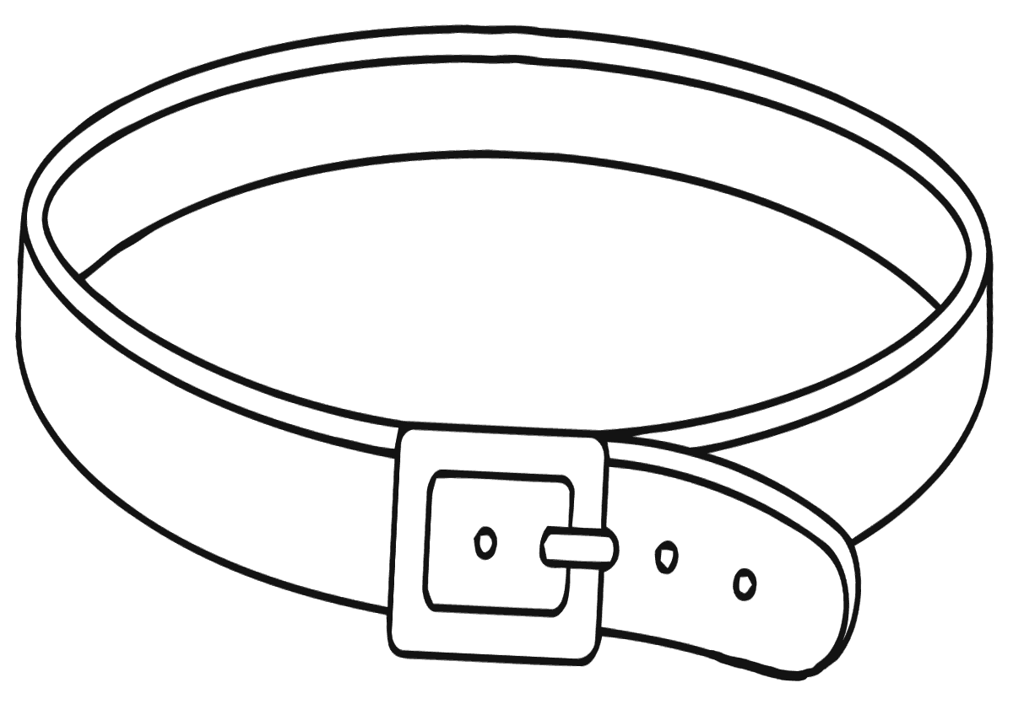2 | 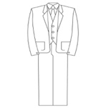 3
- Circle the odd one out. (3*2+6 points)
- bake: | cake | mustard | bread | pie
- peel: | onion | apples | oranges | tuna
- boil: | egg | potatoes | milk | chips
- Underline the correct word. (3*2=6 points)
- Why do you want so many/much eggs?
- There’s a lot of/many lettuce in the fridge.
- Has she got much/many food in the house?
5.Complate the sentences with as…as, too, enough and the words in brackets. (3*3=9 points)
1. Jane’s old cardigan is …for her. (small)
2. My jeans are…yours. (expensive)
3. Frank’s scarf isn’t … . (long)
6.Read and choose. (3*4=12 points)
0. A: What size are you?  B: a) It’s a bigger size. b) Medium. | - A: How much is this belt?  B: a) It’s a deal. b) It’s twenty euros.
- A: Could you pass me the sugar, please?  B: a) Yes, of course. Here you are.  b) No, thanks. Only some tea. | - A: What do you think of this tie?  B: a) It’s too formal.  b) It’s ten euros.

7.Read and choose A, B or C. (3*5=15 points)

MAMA MIA by Cory Anderson
Mama Mia is an Italian restaurant in Liverpool. The décor is very simple and welcoming. The restaurant staff are very friendly, polite and cheerful.
The food is absolutely wonderful! The menu has got a lot of different choices, like soups, salads, pasta, meat and fish dishes. Make sure you leave enough room for the delicious Italian desserts! Mama Mia is not an expensive restaurant. A meal for two costs about 35 euros.
I would definitely recommend Mama Mia. The food is excellent and the atmosphere is very relaxing. Visit Mama Mia for a taste of Italy in Liverpool!

- Mama Mia is in Liverpool. | A Right | B Wrong | C Doesn’t Say
- The restaurant has got Italian décor. | A Right | B Wrong | C Doesn’t Say
- There are many different desserts. | A Right | B Wrong | C Doesn’t Say

66-56=”5”
55-43=”4”
42-33=”3”
32-0=”2”

Test 5 Variant II (Options-7)
- Listen and put a tick(v). (3*5=15 points)
- Where are Larry and Kelly going for dinner? | Alfredo’s  A - V | At Pesto  B | At Nesto  C
- How far is the restaurant? | 1 km  A | 10 km  B | 4 km  C
- How much did Peter pay for the steak? | € 100  A | € 50  B | € 40  C
- Which food does Kim like? | 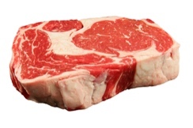 | 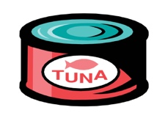 | 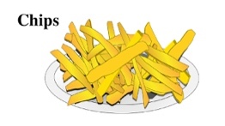
 | A | B | C
- Title the items. (3 points)
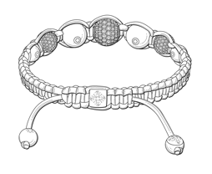 1 | 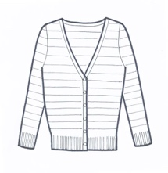 2 | 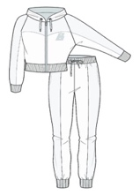 3

3.Circle the odd one out. (3*2=6 points)
- fry: | chicken | pie | fish | egg
- peel: | onion | apples | oranges | tuna
- chop: | mayonnaise | carrots | onions | tomatoes
- Underline the correct word. (3*2=6 points)
- There are only a few/a little carrots left.
- I only need a little/a few more sugar for my tea.
- How many/much money have you got?
5.Complate the sentences with as…as, too, enough and the words in brackets. (3*3=9 p)
1. This skirt doesn’t quite fit me. It’s … . (tight)
2. Lyn’s belt is … Tina’s. (trendy)
3. Tony’s suit isn’t … for the wedding. (formal)
6.Read and choose. (3*4=12 points)
0. A: What size are you?  B: a) It’s a bigger size. b) Medium. | - A: How much is this belt?  B: a) It’s twenty euros.  b) It’s a deal.
- A: Could you pass me the sugar, please?  B: a) No, thanks. Only some tea.  b) Yes, of course. Here you are. | - A: What do you think of this tie?  B: a) It’s ten euros.  b) It’s too formal.
7. Read and choose A, B or C. (3*5=15 points)
MAMA MIA by Cory Anderson
Mama Mia is an Italian restaurant in Liverpool. The décor is very simple and welcoming. The restaurant staff are very friendly, polite and cheerful.
The food is absolutely wonderful! The menu has got a lot of different choices, like soups, salads, pasta, meat and fish dishes. Make sure you leave enough room for the delicious Italian desserts! Mama Mia is not an expensive restaurant. A meal for two costs about 35 euros.
I would definitely recommend Mama Mia. The food is excellent and the atmosphere is very relaxing. Visit Mama Mia for a taste of Italy in Liverpool!

- Mama Mia is in Italy. | A Right | B Wrong | C Doesn’t Say
- The restaurant staff has got uniform from Italy. | A Right | B Wrong | C Doesn’t Say
- The food in the restaurant is different, tasty, but not expensive. | A Right | B Wrong | C Doesn’t Say

66-56=”5”
55-43=”4”
42-33=”3”
32-0=”2”

