Test 1 Variant 1 (Options-6)

- Listen and tick (V) the correct answer. (20 points)
- When is their English lesson?
A | B | C
- What is Sue’s favourite subject?
A | B | C
- Where is the Music lesson?
A ROOM 2A | B ROOM 2D | C ROOM 2C
- Where is Tony from?
A | B | C
- When is the Science lesson this week?
A TUESDAY | B WEDNESDAY | C FRIDAY

2. Write the nationalities.  1) The United Kingdom -…  2) Chile- …….  3) Portugal -….  4) Russia -….  5) Spain -…  - points) | 3.Read and complete the sentences.  (4 points)  clever; quiet; sweet; noisy; hard-working;  - Harry’s dad is very… . He’s at work from nine to eight in the evening.  - Jenny and Steve are very… today. Are they here?  - Georg is a very… student. Look at his marks!  - Be quiet, please! You are so…!
4.Сomplete the sentences. Use: am, is, isn’t, are, aren’t (3 points )
- I…a student in Italy.
- They…from Turkey. They’re from Italy.
- …Jack in your class?
5.Read and underline. (5 points )
- Who/What are you?
- Look at my/I new computer game!
- We/Our are in the same class.
- When/Where is he from?
- She is my new friend and she/her name is Betty.
6. Read the homepage. Write T (True) or F (False) for sentences. (10 points)
SILVIA BROWN’S HOMEPAGE

Hi, my name is Silvia and I’m eleven. I’m from Glasgow, Scotland. I am a student at McGraw School. I’m in Class 6B.
My favourite school subjects are History and Geography, but I’m not very good at Maths or Science. My favourite teacher is Mr Green. He’s really nice!
My best friend is Maria. She is twelve and she is Russian. We are in the same class at school. Her favourite subjects are Maths and English.
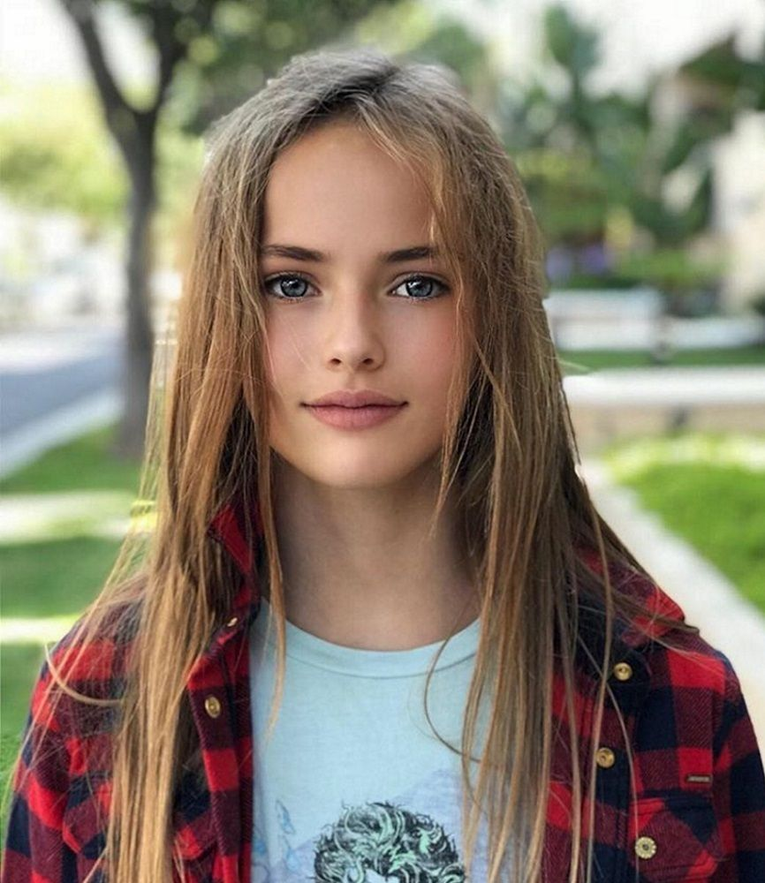

- Silvia is fifteen.
- Silvia is Scottish.
- Silvia’s favourite subject is Maths.
- Silvia’s favourite teacher is Mr Brown.
- Silvia’s best friend is from Russia.

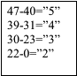
Test 1 Variant 2 (Options-6)

- Listen and tick (V) the correct answer. (20 points)
- When is their English lesson?
A | B | C
- What is Sue’s favourite subject?
A | B | C
- Where is the Music lesson?
A ROOM 2A | B ROOM 2D | C ROOM 2C
- Where is Tony from?
A | B | C
- When is the Science lesson this week?
A TUESDAY | B WEDNESDAY | C FRIDAY

2. Write the nationalities. (5 points)  1) The USA -…  2) Greese- …….  3) Argentina -….  4) Poland -….  5) Italy -… | 3.Read and complete the sentences.  (4 points)  quiet; trendy; favourite; sweet; lucky;  - What is your ….number? Thirteen?  - Are these flowers for me? You’re very…!  - My…subject is IT.  - Becky is very… . Her clothes are super!
4. Сomplete the sentences. Use: am, is, isn’t, are, aren’t (3 marks )
- Mr Evans… rude. He’s very friendly.
- Becky and I … very trendy.
- Sue … sweet and polite.
- Read and underline. (5 marks )
- How/What is the name of your school?
- Ann and Tina are sisters. You/They are my new friends.
- How/What old are you?
- We are in Year 6 and that’s my/our new English teacher.
- What/When is our Geography lesson?
6. Read the homepage. Write T (True) or F (False) for sentences. (10 points)
SAMANTA BROWN’S HOMEPAGE

Hi, my name is Samanta and I’m twelve. I’m from Landon, England. I am a student at McGraw School. I’m in Class 6B.
My favourite school subjects are IT and Art, but I’m not very good at Maths or Science. My favourite teacher is Mr Brown. He’s really nice!
My best friend is Anna. She is fifteen and she is Russian. We are in the same class at school. Her favourite subjects are Maths and English.
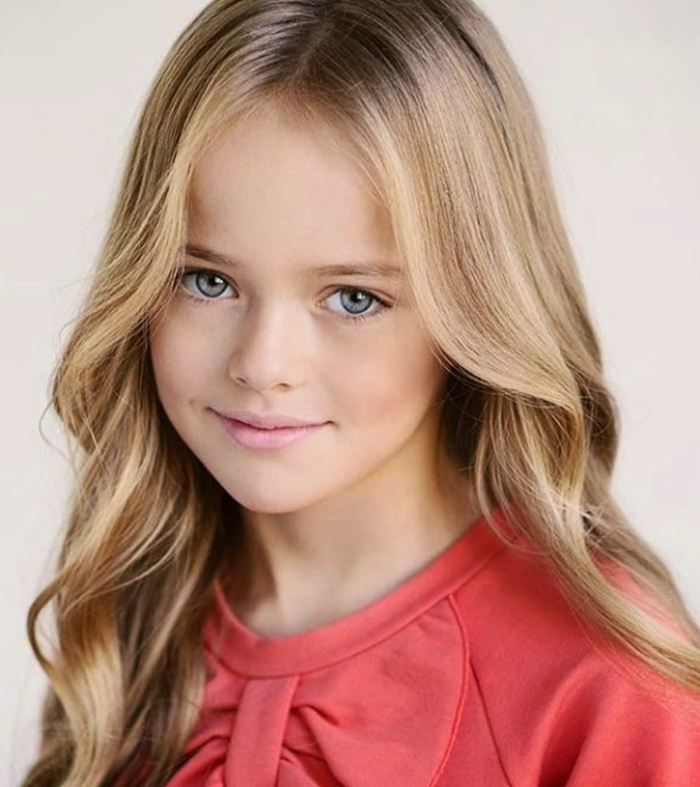

- Samanta is fifteen.
- Samanta is England.
- Samanta’s favourite subject is Science.
- Samanta’s favourite teacher is Mr Green.
- Anna is in a different school.

47-40=”5”
39-31=”4”
30-23=”3”
22-0=”2”

